NAME: Soham Saha

SECTION: CSE2A

CLASS ROLL: 61

ENROLLMENT NUMBER: 12019009001389

ASSINGEMENT DATE: 10th APRIL,2021

SUBJECT: OOP’S JAVA

1)

import java.util.*;

class q1

{

public static void main(String args[])

{

Scanner in = new Scanner(System.in);

int num,f=1;

System.out.println("Enter the number >> ");

num = in.nextInt();

for(int i = 1;i<=num;i++)

{

f*=i;

}

System.out.println("The Factroial is: "+f);

}

}

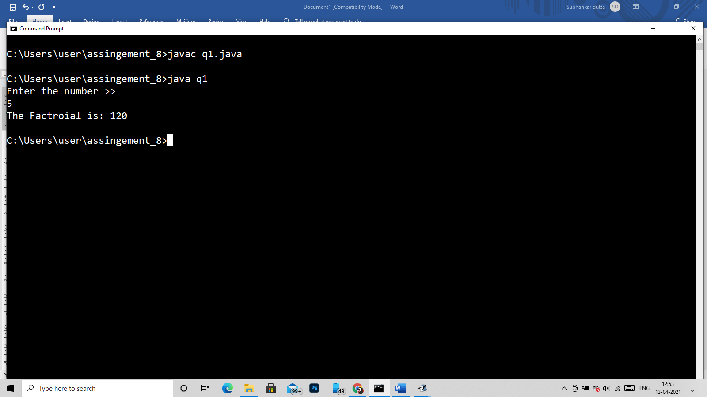

2)

import java.util.*;

class q2

{

public static void main(String args[])

{

Scanner in = new Scanner(System.in);

System.out.println("Enter the string:>> ");

String str = in.next();

int len = str.length(),flag=0;

char st[] = new char[50];

st = str.toCharArray();

for(int i = 0;i<len/2 ;i++)

{

if(st[i]!=st[len-i-1])

{

flag=1;

}

}

if(flag==0)

System.out.println("Yes it is palindrom String");

else

System.out.println("No it is not a palindrom string");

}

}

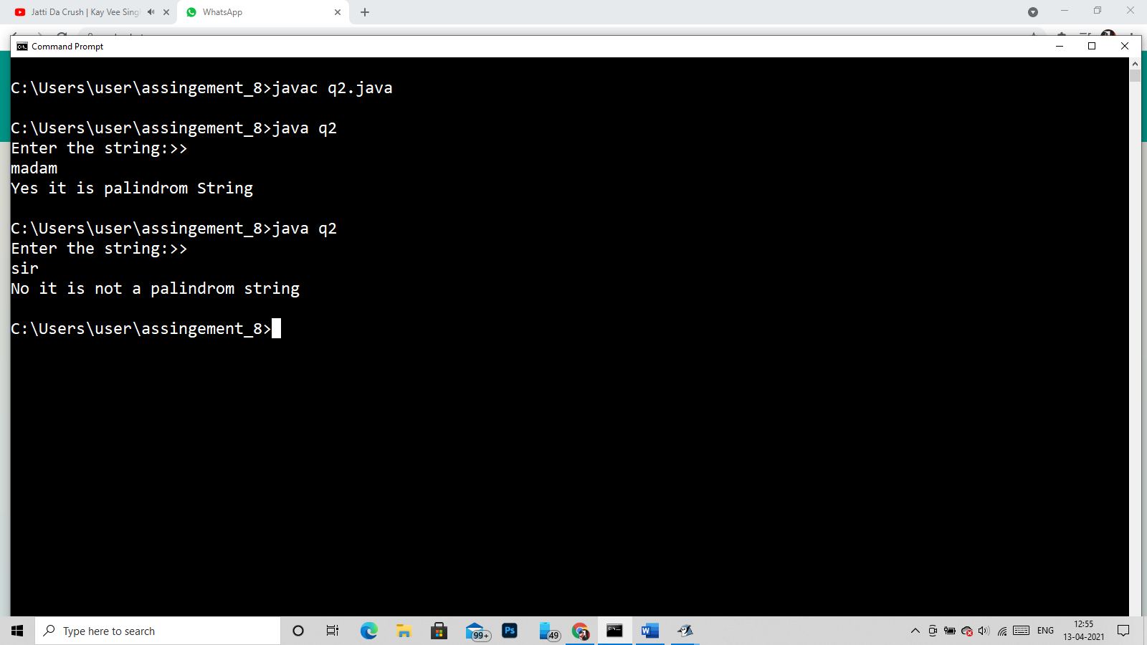

3)

import java.util.*;

class q3

{

public static void main(String args[])

{

Scanner in = new Scanner(System.in);

String str1,str2,str3;

System.out.println("Enter the string 1:>> ");

str1= in.next();

System.out.println("Enter the string 2:>> ");

str2= in.next();

str3 = str1+str2;

System.out.println("The merged String is::> "+str3);

}

}

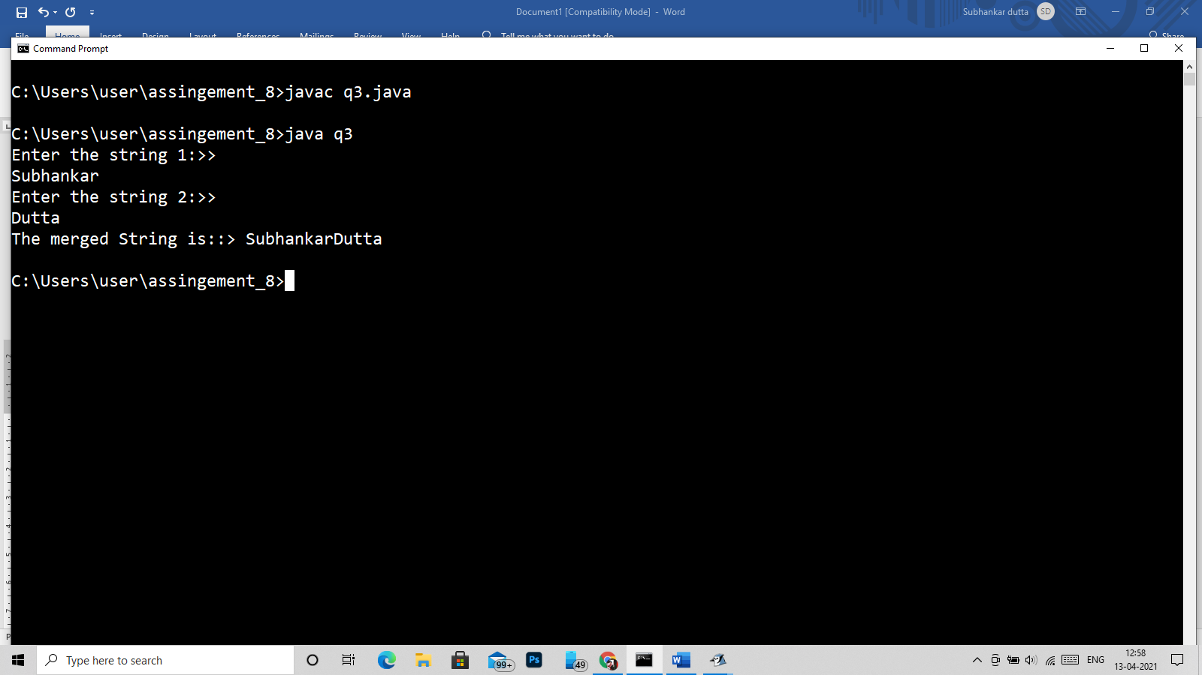

4)

import java.util.*;

class q4

{

public static void main(String args[])

{

Scanner in = new Scanner(System.in);

System.out.println("Enter the string:>> ");

String str = in.next();

int len = str.length(),flag=0;

char st[] = new char[50];

st = str.toCharArray();

for(int i = len-1;i>=0;i--)

{

System.out.print(st[i]);

}

}

}

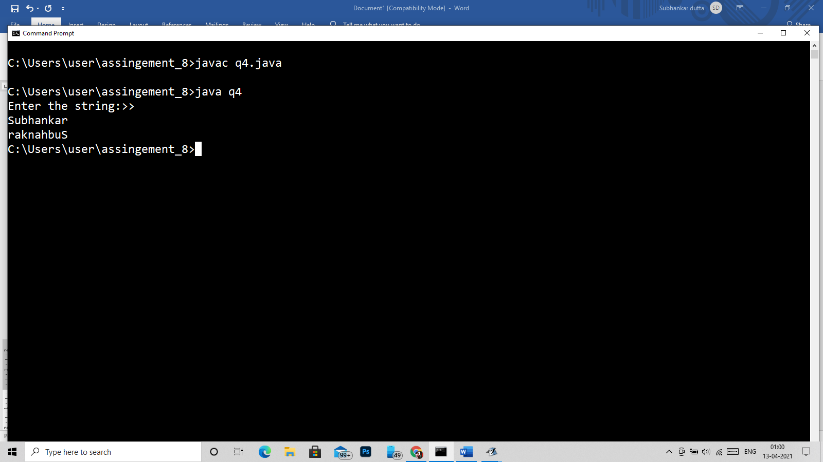

5)

import java.util.*;

class q5

{

public static void main(String args[])

{

Scanner in = new Scanner(System.in);

String str1,str2,str3;

System.out.println("Enter the string 1:>> ");

str1= in.next();

System.out.println("Enter the string 2:>> ");

str2= in.next();

str3 = str1.concat(str2);

System.out.println("The merged String is::> "+str3);

}

}

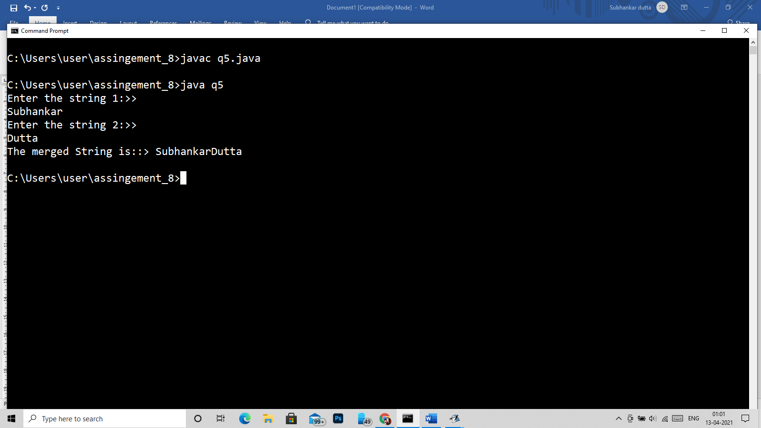

6)

import java.util.*;

class q6

{

public static void main(String args[])

{

Scanner in = new Scanner(System.in);

System.out.println("Enter the string:>> ");

String str = in.next();

System.out.println("Enter the charecter:>> ");

char ch = in.next().charAt(0);

System.out.println("The index is:>> "+str.indexOf(ch));

}

}

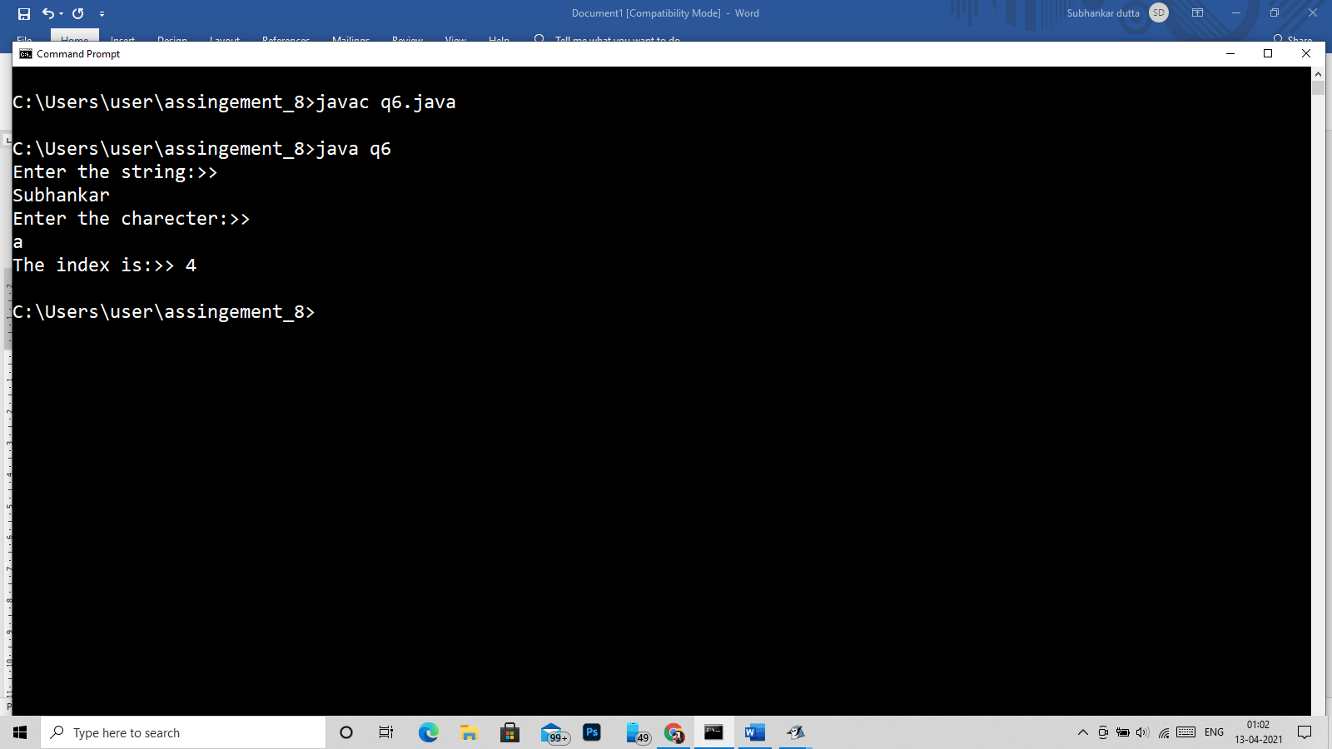

7)

import java.util.*;

class q7

{

public static void main(String args[])

{

Scanner in = new Scanner(System.in);

System.out.println("Enter the string:>> ");

String str = in.nextLine();

int len = str.length(),flag=0;

System.out.println("The length of given str is:::> "+len);

}

}

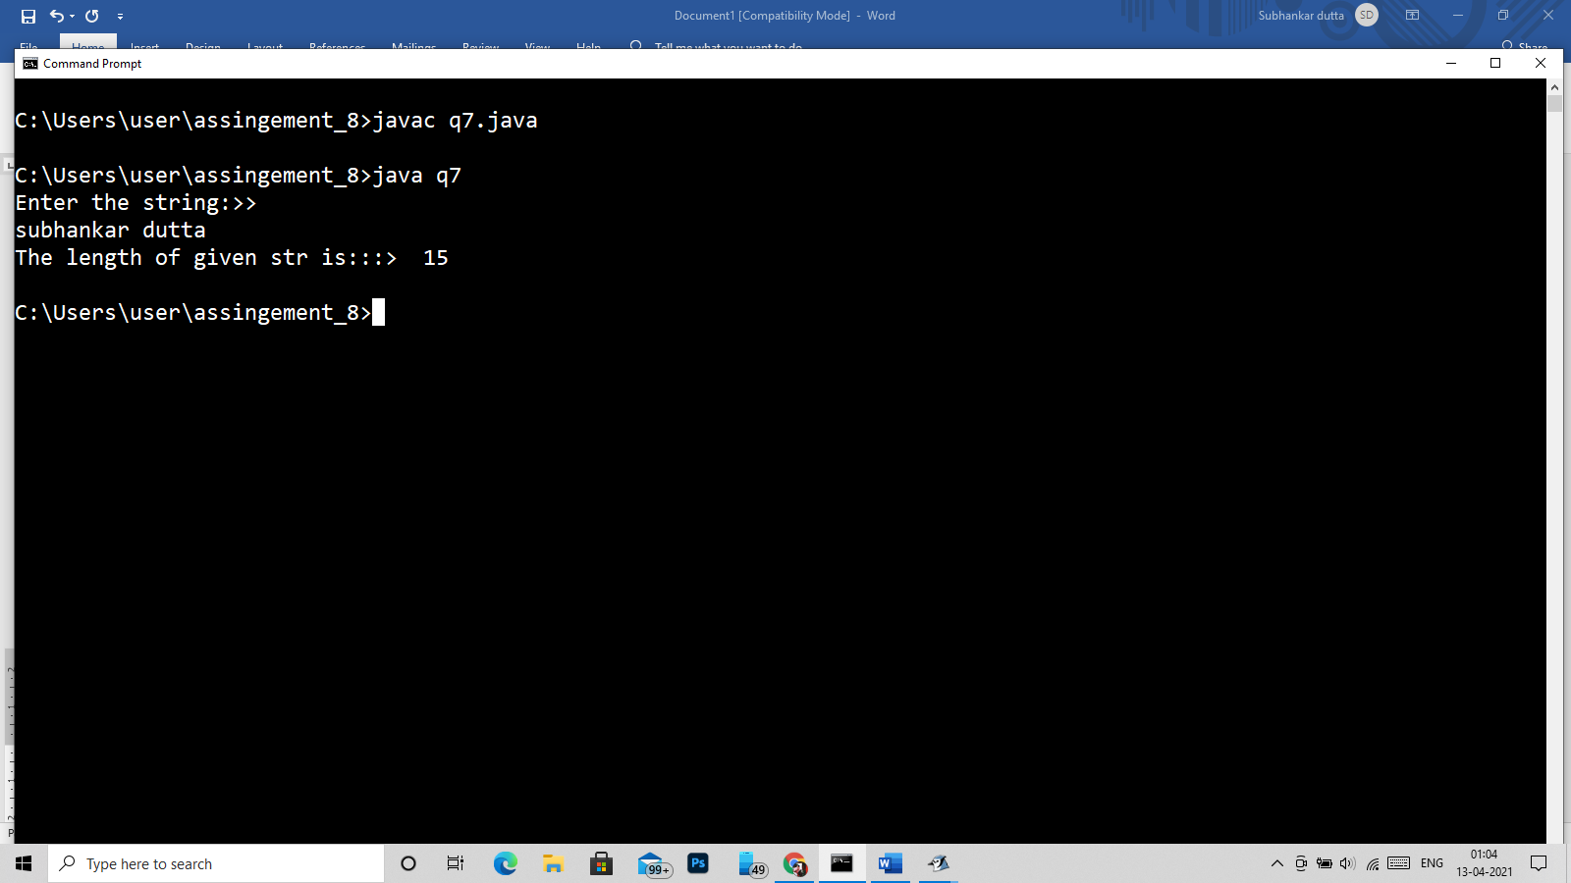

8)

import java.util.*;

class q8

{

public static void main(String args[])

{

Scanner in = new Scanner(System.in);

System.out.println("Enter the string:>> ");

String str = in.nextLine();

System.out.println("Enter the sub string:>> ");

String ch = in.nextLine();

System.out.println("The index is:>> "+str.indexOf(ch));

}

}

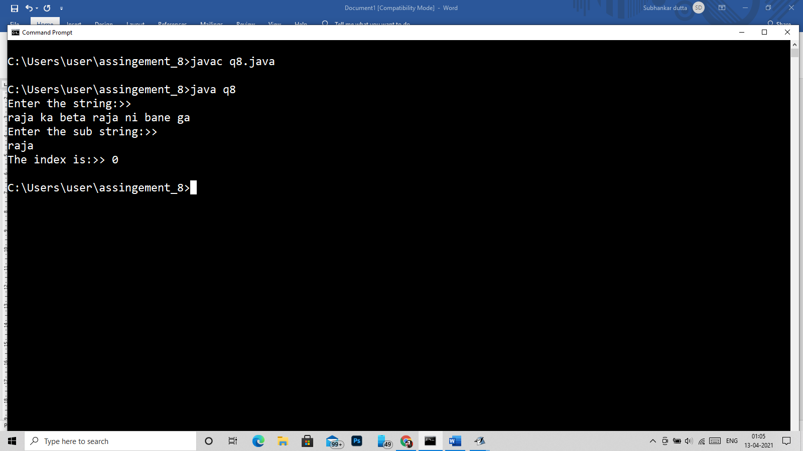

9)

import java.util.*;

class q9

{

public static void main(String args[])

{

Scanner in = new Scanner(System.in);

System.out.println("Enter the string:>> ");

String str = in.nextLine();

int len = str.length(),flag=0;

char st[] = new char[50];

st = str.toCharArray();

for(int i =0;i<len;i++)

{

if(st[i]!=' ')

System.out.print(st[i]);

}

}

}

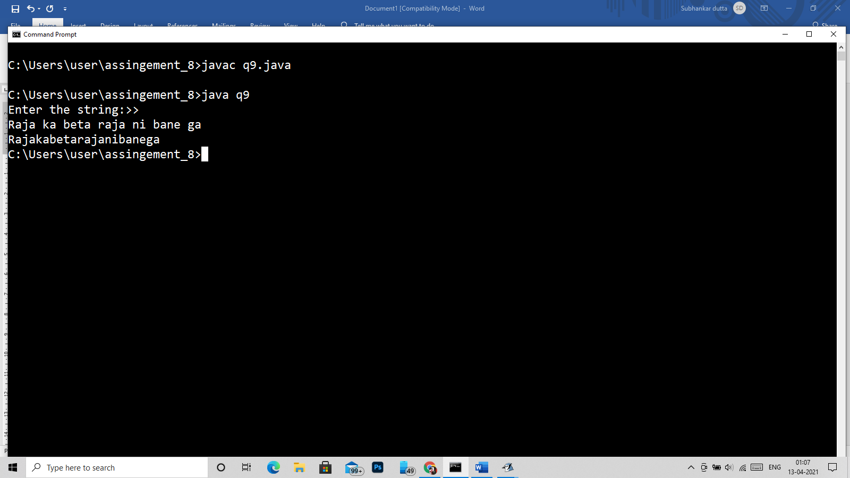

10)

import java.util.*;

class q10

{

public static void main(String args[])

{

Scanner in = new Scanner(System.in);

String str1,str2,str3;

System.out.println("Enter the string 1:>> ");

str1= in.nextLine();

System.out.println("Enter the string 2:>> ");

str2= in.nextLine();

System.out.println("The compairing String is::> "+str1.equals(str2));

}

}

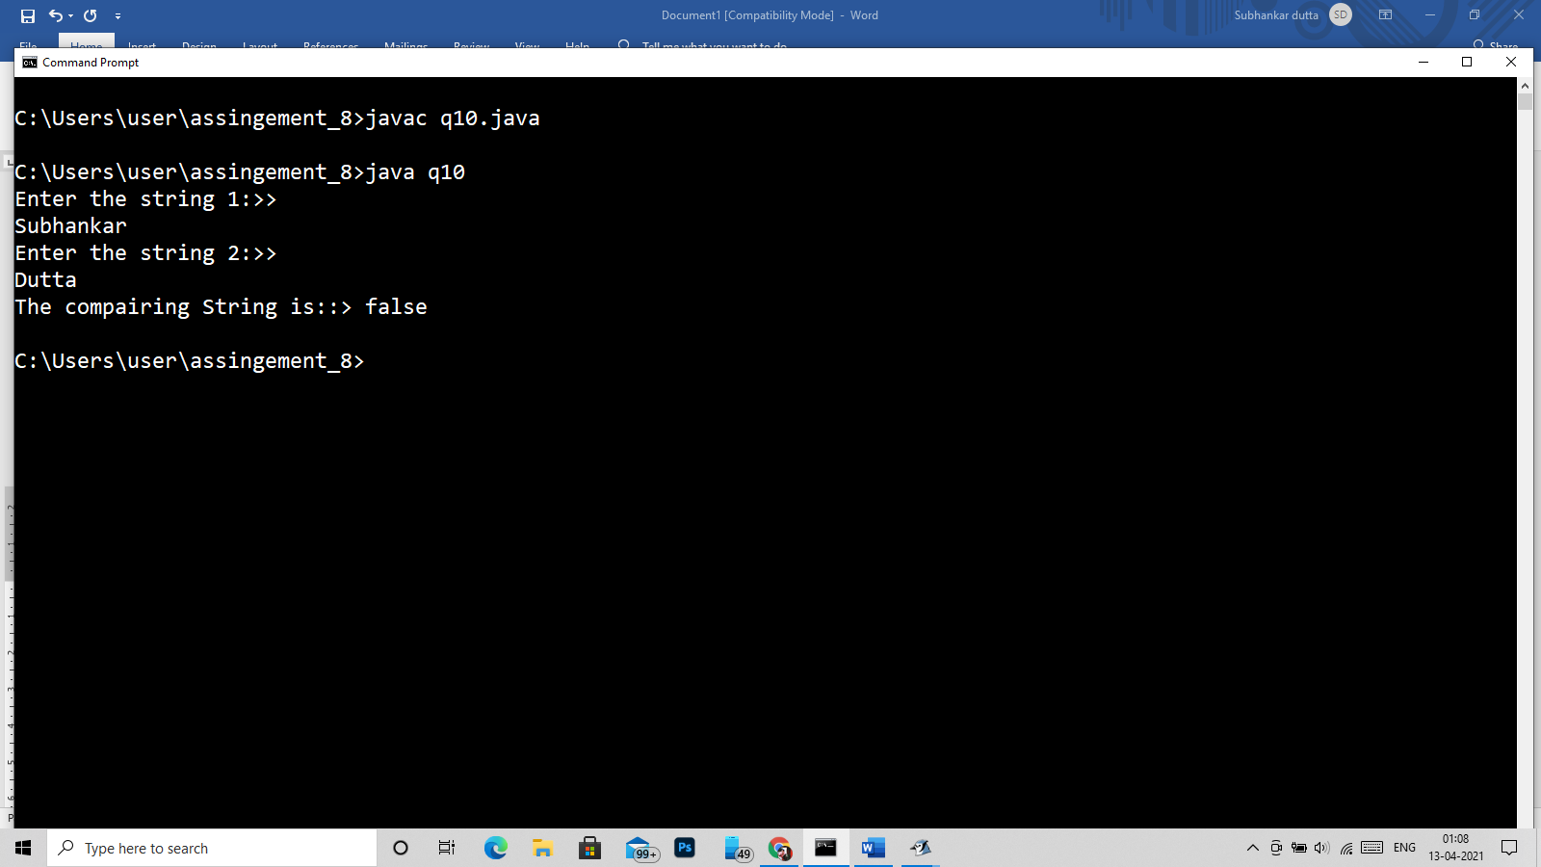

11)

import java.util.*;

class q11

{

public static void main(String args[])

{

Scanner in = new Scanner(System.in);

System.out.println("Enter the string:>> ");

String str1 = in.nextLine();

int len1 = str1.length(),flag=0;

char st1[] = new char[50];

st1 = str1.toCharArray();

System.out.println("Enter the string:>> ");

String str2 = in.nextLine();

int len2 = str2.length();

char st2[] = new char[50];

st2 = str2.toCharArray();

int i;

if(len1>len2)

{

for(i=0;i<len2;i++)

{

System.out.println(st1[i]+"-"+st2[i]+":"+((int)st1[i]-(int)st2[i]));

}

for(i=len2;i<len1;i++)

{

System.out.println(st1[i]);

}

}

else

{

for(i=0;i<len1;i++)

{

System.out.println(st2[i]+"-"+st1[i]+":"+((int)st2[i]-(int)st1[i]));

}

for(i=len1;i<len2;i++)

{

System.out.println(st2[i]);

}

}

}

}

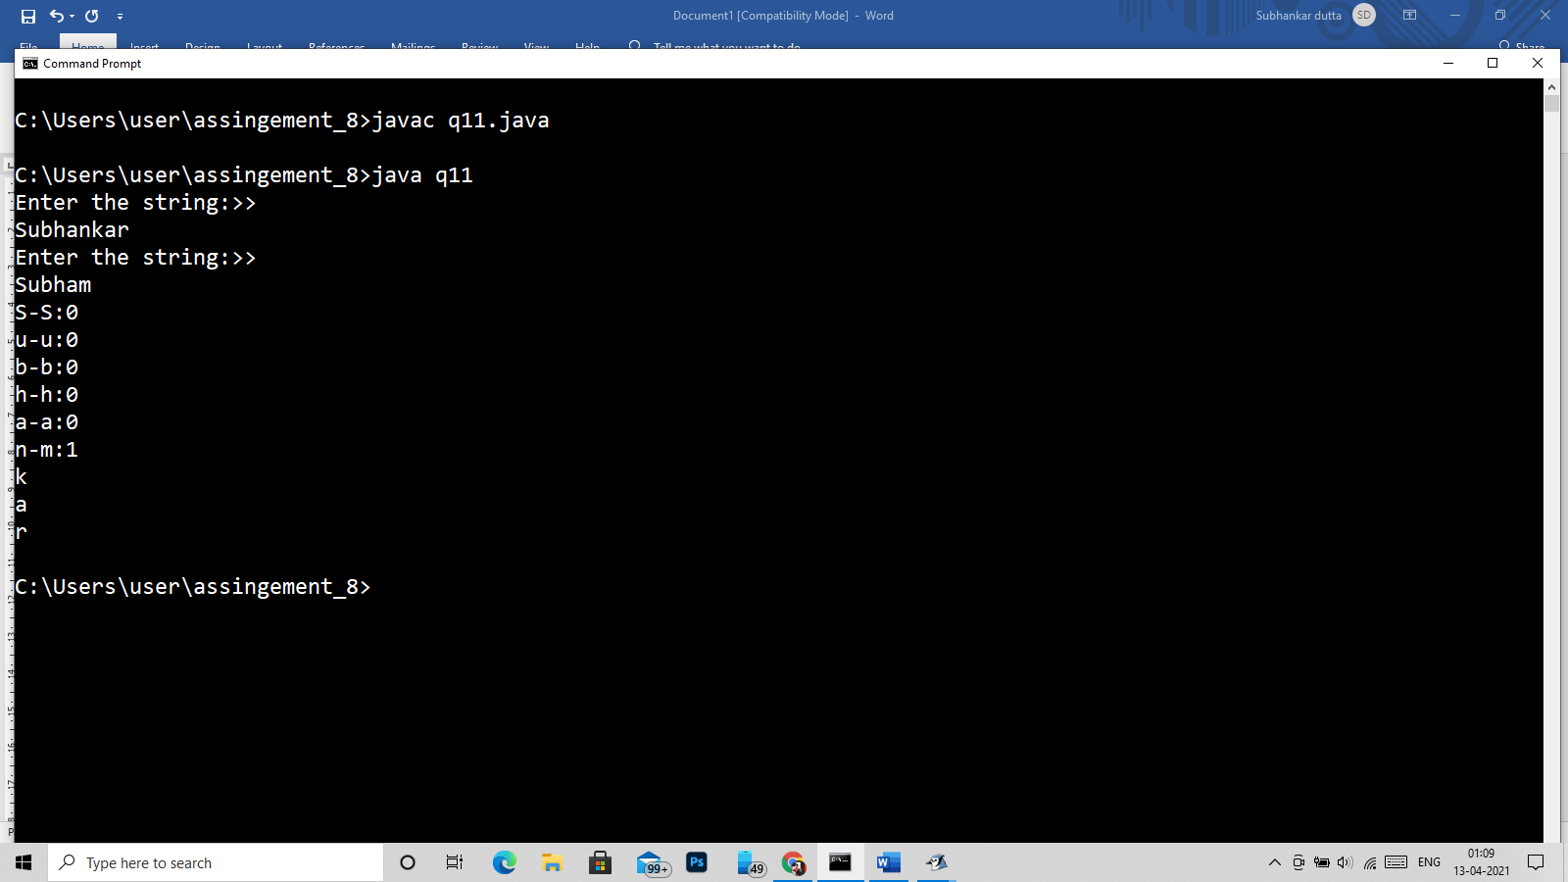

12)

import java.util.*;

class q12

{

public static void main(String args[])

{

Scanner in = new Scanner(System.in);

System.out.println("Enter the string:>> ");

String str1 = in.nextLine();

System.out.println("Enter the string:>> ");

String str2 = in.nextLine();

System.out.println("the equal case is: "+str1.equals(str2));

}

}

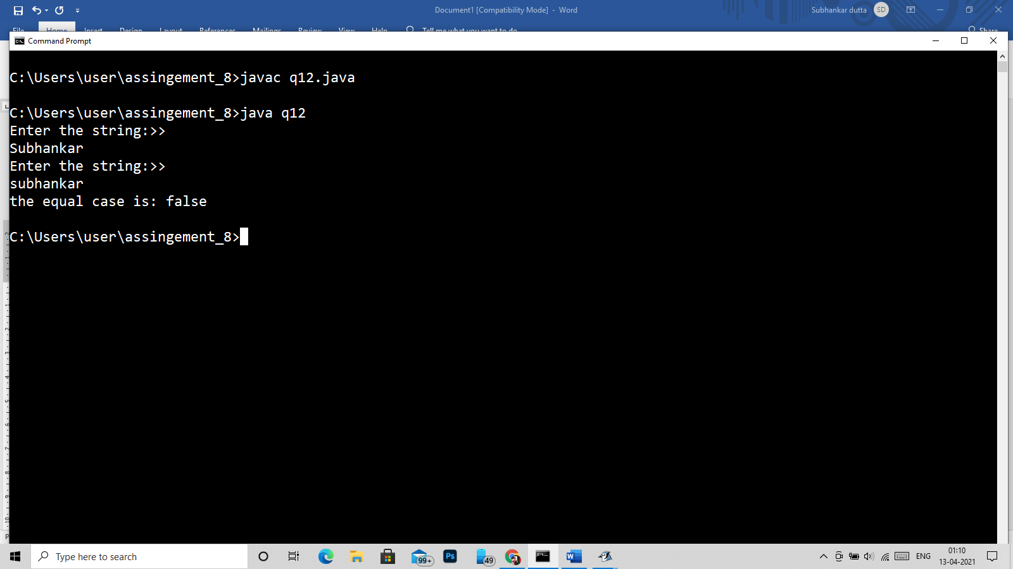

Q13)

import java.util.*;

class q13

{

public static void main(String args[])

{

Scanner in = new Scanner(System.in);

System.out.println("Enter the string:>> ");

String str1 = in.nextLine();

System.out.println("Enter the string:>> ");

String str2 = in.nextLine();

System.out.println("the equal Ignore case is: "+str1.equalsIgnoreCase(str2));

}

}

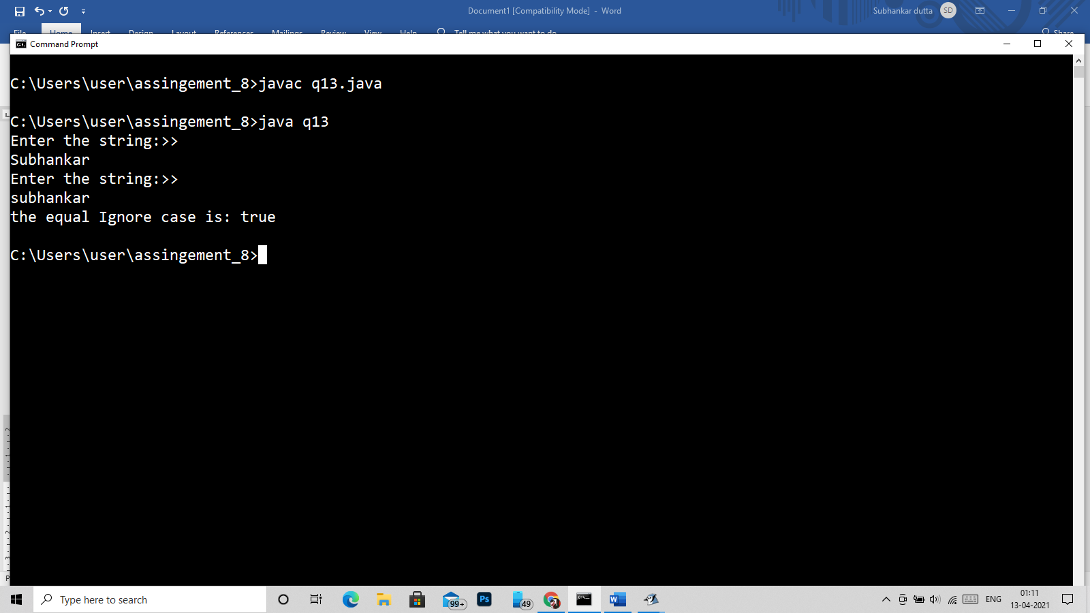

14)

import java.util.*;

class q14

{

public static void main(String args[])

{

Scanner in = new Scanner(System.in);

System.out.println("Enter the string:>> ");

String str1 = in.nextLine();

System.out.println("Enter the string:>> ");

String str2 = in.nextLine();

System.out.println("the compare case is: "+str1.compareTo(str2));

}

}

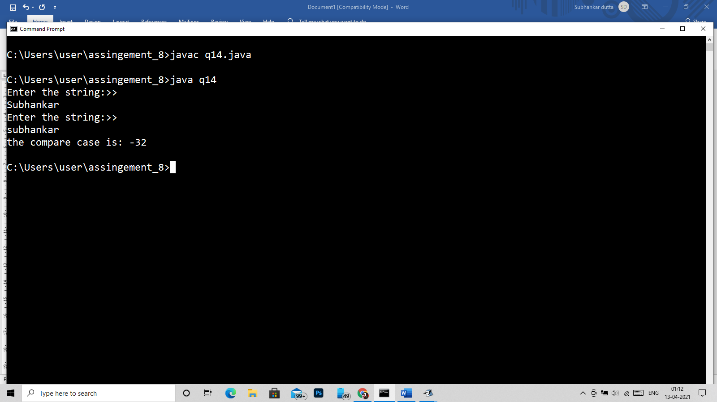

15)

import java.util.*;

class q15

{

public static void main(String args[])

{

Scanner in = new Scanner(System.in);

System.out.println("Enter the string:>> ");

String str1 = in.nextLine();

System.out.println("Enter the string:>> ");

String str2 = in.nextLine();

System.out.println("the compare ignore case is: "+str1.compareToIgnoreCase(str2));

}

}

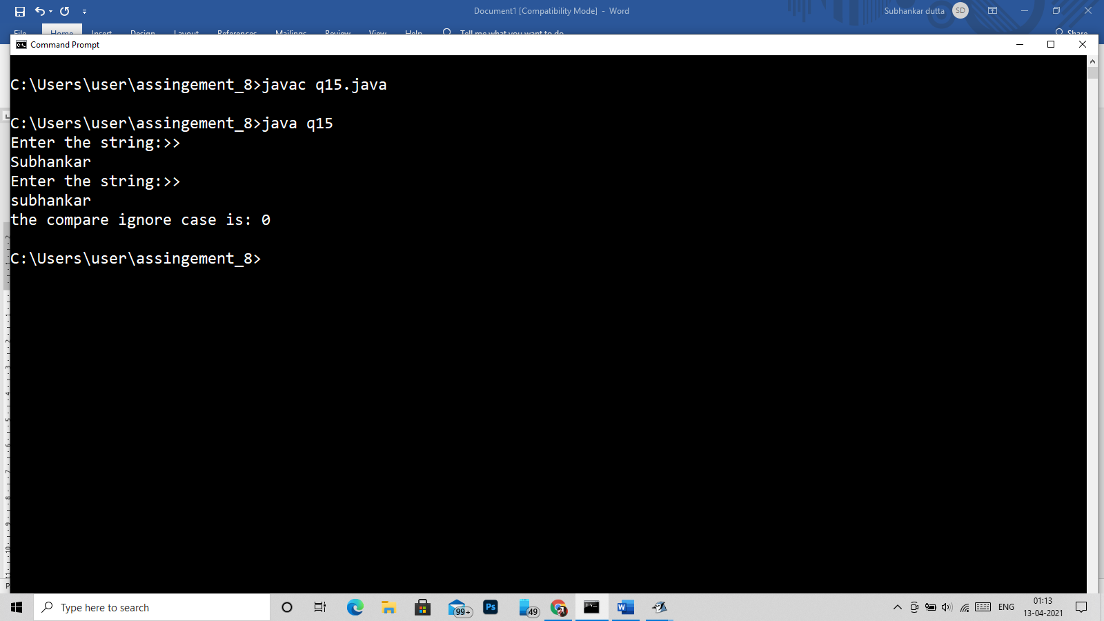

16)

import java.util.*;

class q16

{

public static void main(String args[])

{

Scanner in = new Scanner(System.in);

System.out.println("Enter the string:>> ");

String str1 = in.nextLine();

System.out.println("Enter the charecter or string to be replace:>> ");

String str3 = in.nextLine();

System.out.println("Enter the new charecter or string:>> ");

String str2 = in.nextLine();

System.out.println("the compare ignore case is: "+str1.replace(str3,str2));

}

}

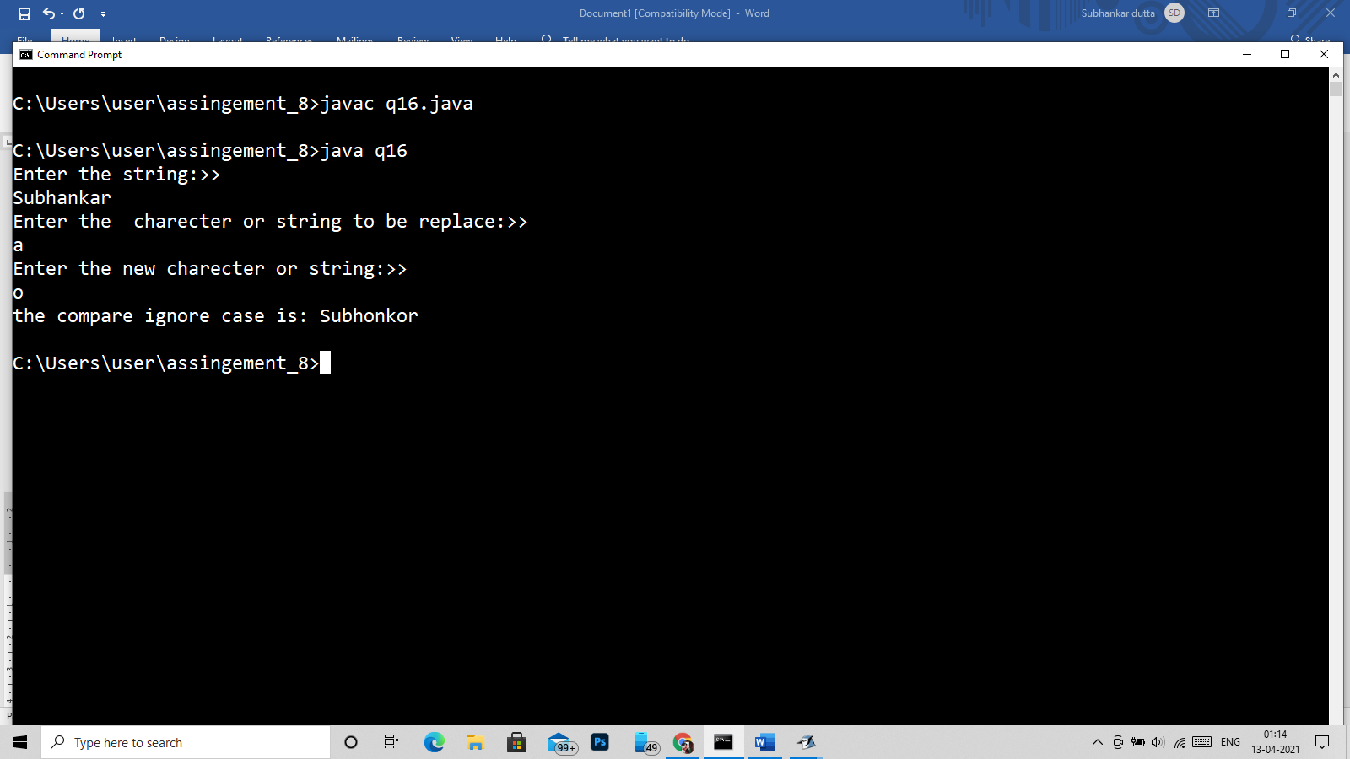

17)

import java.util.*;

class q17

{

public static void main(String args[])

{

Scanner in = new Scanner(System.in);

System.out.println("Enter the string:>> ");

String str1 = in.nextLine();

System.out.println("Enter the charecter or string:>> ");

String str3 = in.nextLine();

System.out.println("the last occerence of second string is: "+str1.lastIndexOf(str3));

}

}

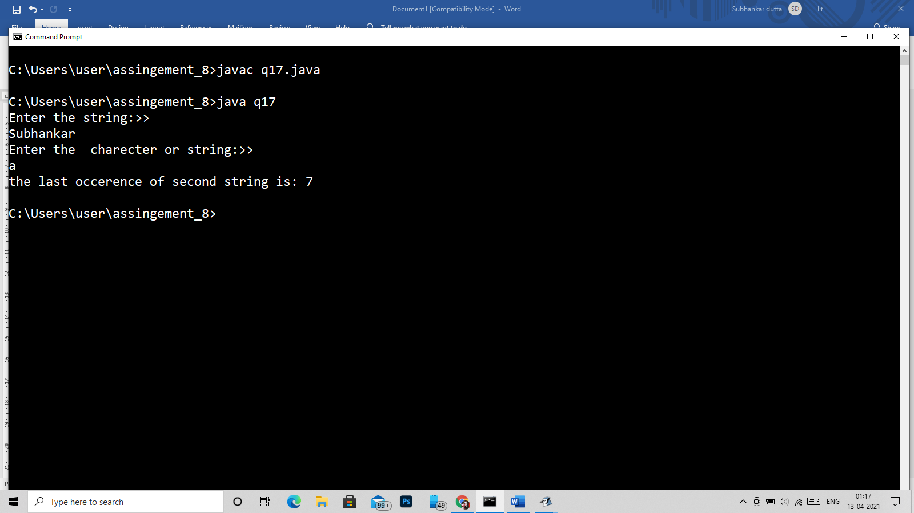

18)

import java.util.*;

class q18

{

public static void main(String args[])

{

Scanner in = new Scanner(System.in);

System.out.println("Enter the string:>> ");

String str1 = in.nextLine();

System.out.println("Enter the charecter or string to be remove:>> ");

String str3 = in.nextLine();

System.out.println("afert removing: "+str1.replace(str3,""));

}

}

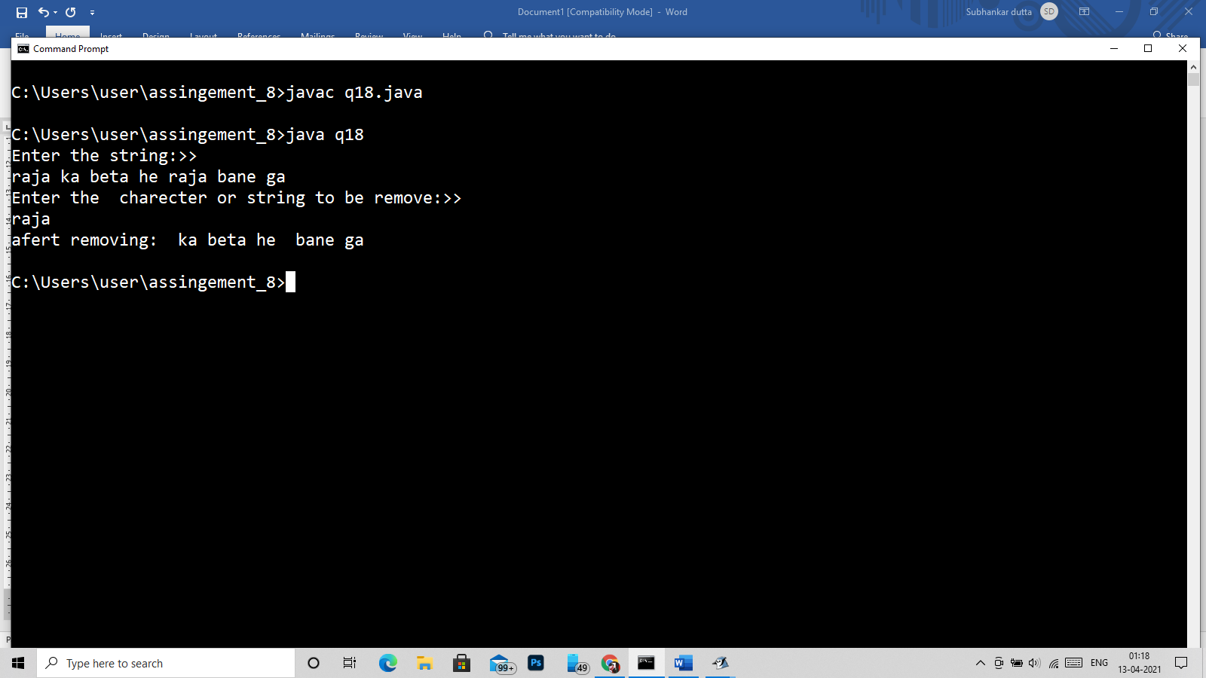

19)

import java.util.*;

class q19

{

public static void main(String args[])

{

Scanner in = new Scanner(System.in);

System.out.println("Enter the string:>> ");

String str1 = in.nextLine();

System.out.println("Enter the charecter or string to be replace:>> ");

String str3 = in.nextLine();

System.out.println("Enter the new charecter or string :>> ");

String str2 = in.nextLine();

System.out.println("afert removing: "+str1.replace(str3,str2));

}

}

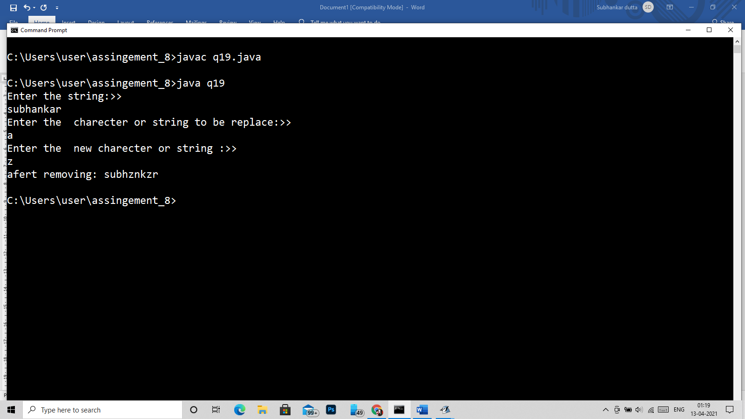

Q20)

import java.util.*;

class q20

{

public static void main(String args[])

{

Scanner in = new Scanner(System.in);

System.out.println("Enter the string:>> ");

String str = in.nextLine();

int len = str.length(),flag=0;

char st[] = new char[50];

st = str.toCharArray();

int i;

for(i=len-1;i>=0;i--)

{

System.out.print(st[i]);

}

}

}

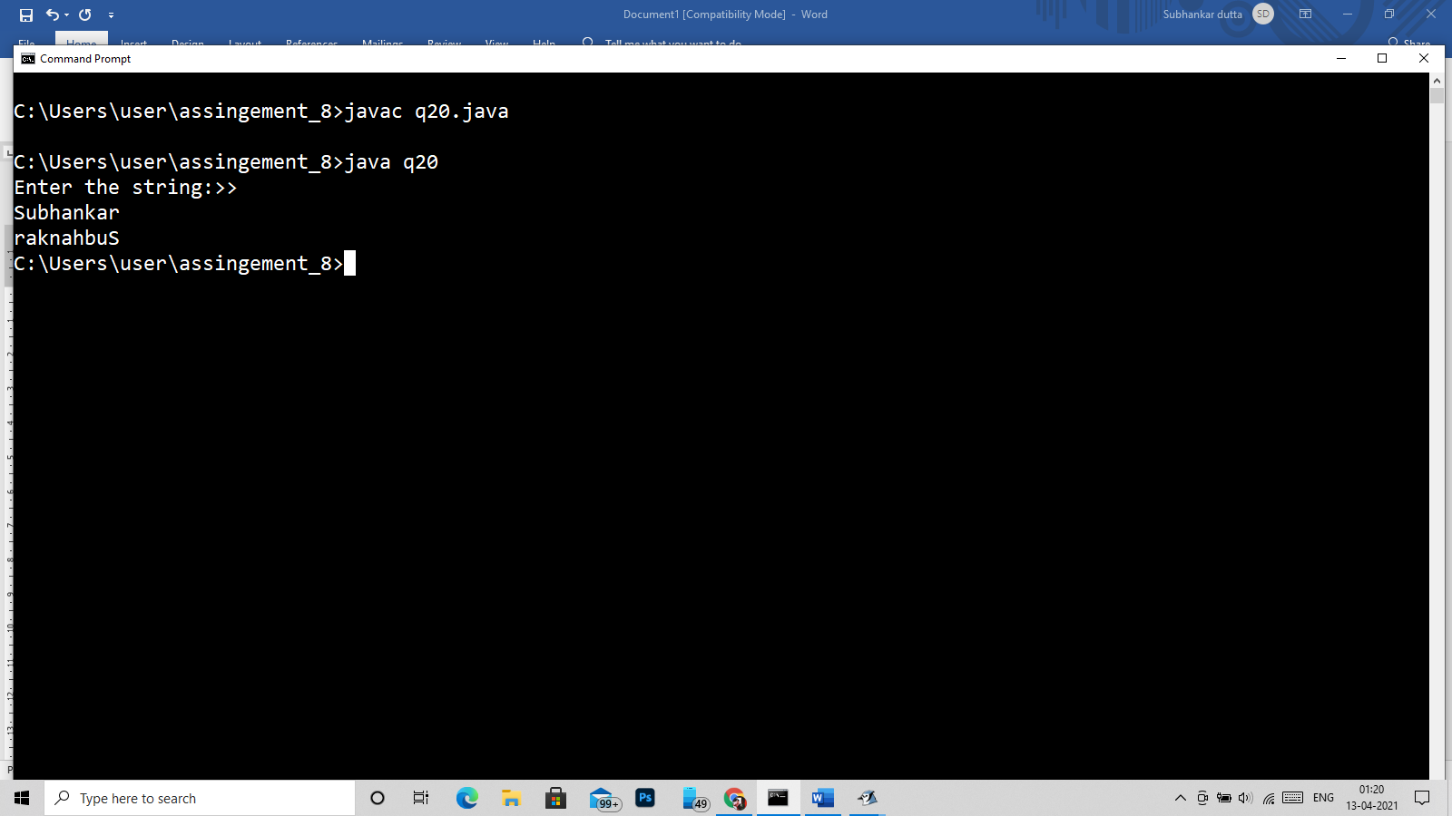

21)

import java.util.*;

class q21

{

public static void main(String args[])

{

Scanner in = new Scanner(System.in);

System.out.println("Enter the string:>> ");

String str1 = in.nextLine();

System.out.println("Enter the charecter or string to be searched:>> ");

String str3 = in.nextLine();

System.out.println("str1.contains(str3): "+str1.contains(str3));

}

}

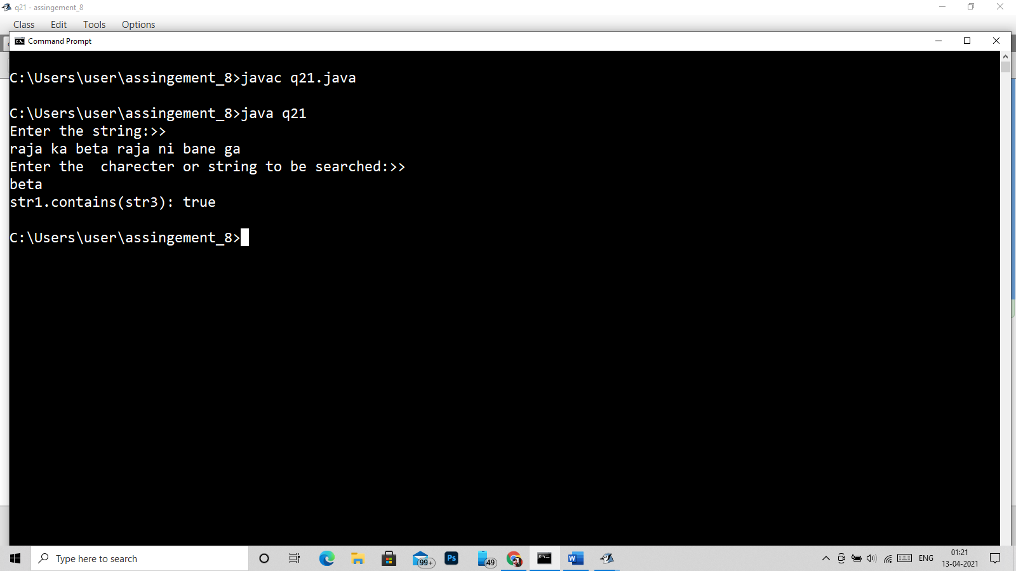

22)

import java.util.*;

class q22

{

public static void main(String args[])

{

Scanner in = new Scanner(System.in);

System.out.println("Enter the string:>> ");

String str1 = in.nextLine();

String[] arr = str1.split(" ");

for(String a: arr)

{

System.out.println(a);

}

}

}

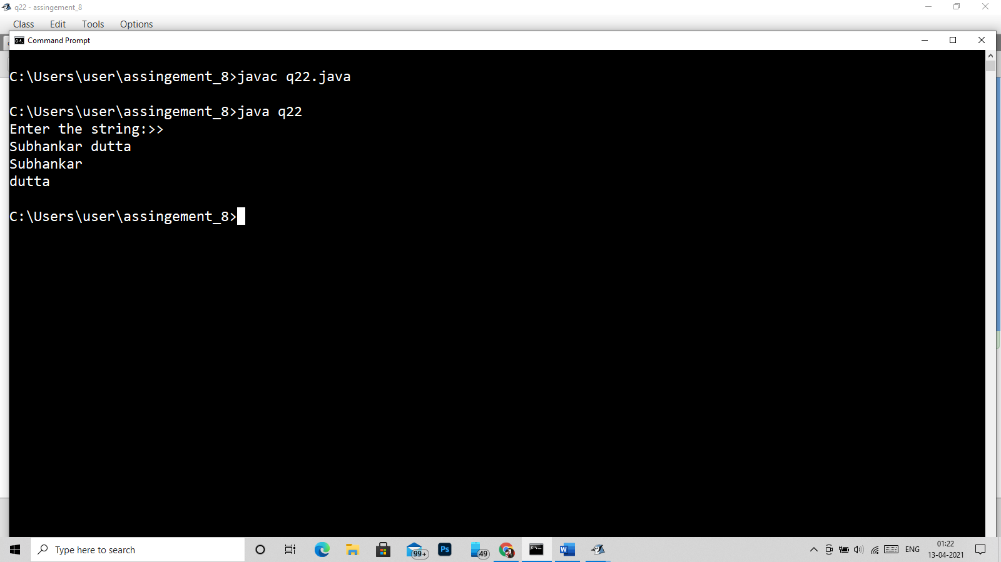

Q23)

import java.util.*;

class q23

{

public static void main(String args[])

{

Scanner in = new Scanner(System.in);

System.out.println("Enter the string:>> ");

String str1 = in.nextLine();

System.out.println("Enter the charecter or string to be searched:>> ");

String str3 = in.nextLine();

System.out.println("in index : "+str1.indexOf(str3));

}

}

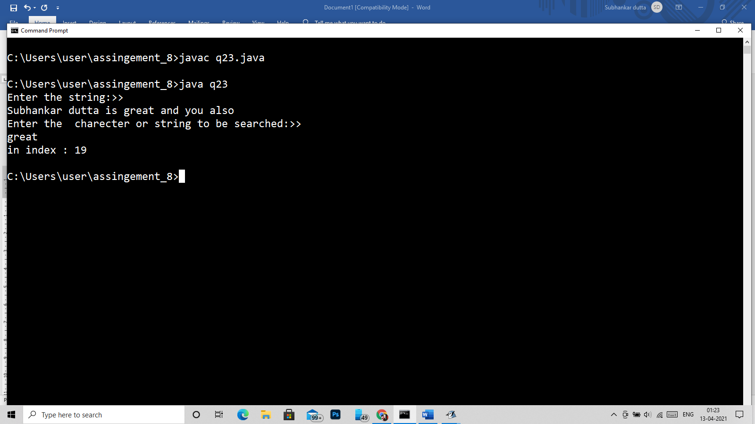

24)

import java.util.*;

class q24

{

public static void main(String args[])

{

Scanner in = new Scanner(System.in);

System.out.println("Enter the string:>> ");

String str1 = in.nextLine();

System.out.println("Enter the charecter or string to be replaced:>> ");

String str3 = in.nextLine();

System.out.println("Enter the new charecter or string to be replaced:>> ");

String str2 = in.nextLine();

System.out.println("afert removing: "+str1.replaceAll(str3,str2));

}

}

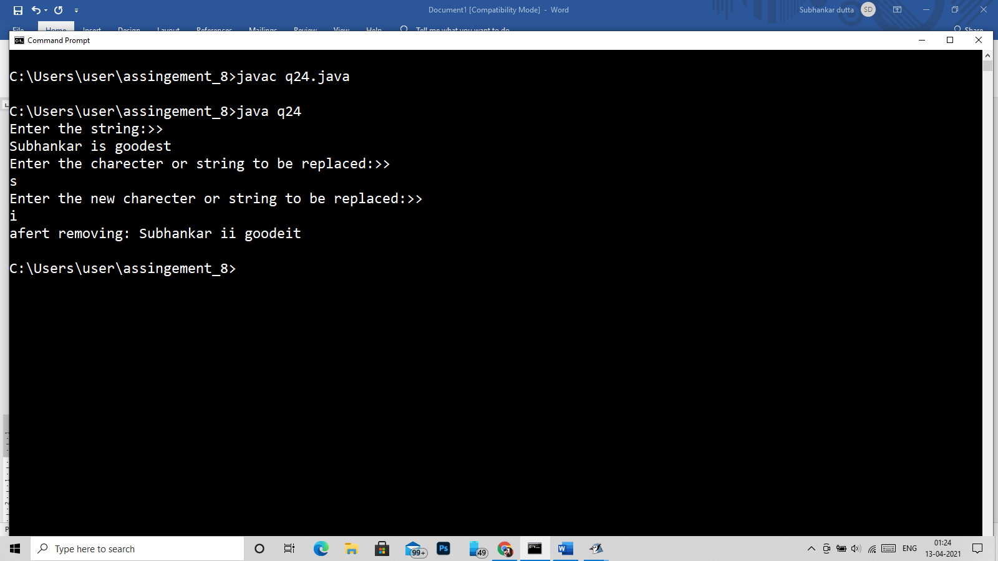

25)

import java.util.*;

class q25

{

public static void main(String args[])

{

Scanner in = new Scanner(System.in);

System.out.println("Enter the string:>> ");

String str = in.nextLine();

str = str;

int len = str.length(),flag=0;

char st[] = new char[50];

st = str.toCharArray();

int i;

for(i=0;i<len;i++)

{

//jane de na bhai q piche para hai -_-

if(i==0)

{

st[i]=(char)((int)st[i]-32);

}

if(st[i]==' '&&(st[i+1]>='a' && st[i+1]<='z'))

{

st[i+1]=(char)((int)st[i+1]-32);

}

System.out.print(st[i]);

}

}

}

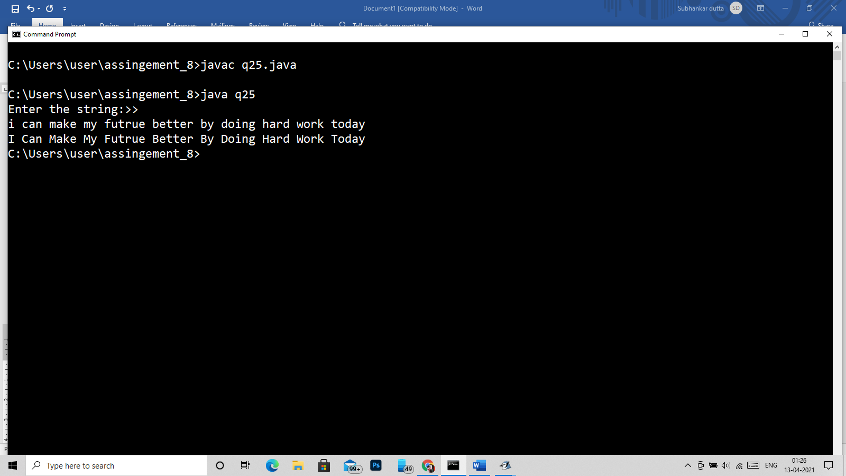

26)

import java.util.*;

class q26

{

public static void main(String args[])

{

Scanner in = new Scanner(System.in);

System.out.println("Enter the string:>> ");

String str = in.nextLine();

str=str+" ";

int len = str.length(),flag=0;

String word[]=new String[20];

char st[] = new char[150],cword[]= new char[20];

st = str.toCharArray();

int i,j=0,w=0;

for(i=0;i<len;i++)

{

if(st[i]!=' ')

{

cword[j]=st[i];

j++;

}

else

{

String w1 = new String(cword);

word[w]=w1;

w++;

j=0;

cword=new char[20];

}

}

String wk;

for(i=0;i<w;i++)

{

wk=word[i];

for(j=i+1;j<w;j++)

{

if(wk.equals(word[j]))

{

word[j]="null";

}

}

}

for(i=0;i<w;i++)

{

if(!word[i].equals("null"))

System.out.print(word[i]+" ");

}

}

}

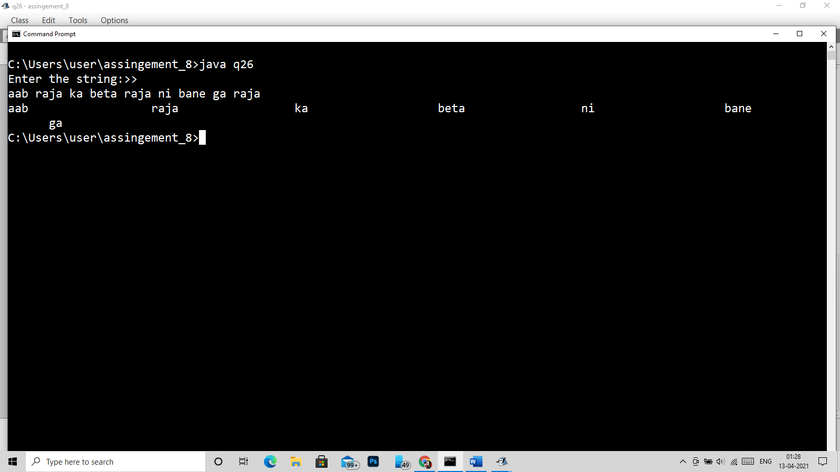

Q27)

import java.util.*;

class q27

{

public static void recrev(char ch[],int n)

{

if(n>-1)

{

System.out.print(ch[n]);

recrev(ch,n-1);

}

else

{

return;

}

}

public static String itrrev(char ch[],int n)

{

char ch1;

for(int i =0;i<n/2;i++)

{

ch1 = ch[i];

ch[i]=ch[n-i-1];

ch[n-i-1] = ch1;

}

String s = new String(ch);

return s;

}

public static void main(String args[])

{

Scanner in = new Scanner(System.in);

System.out.println("Enter the string:>> ");

String str = in.nextLine();

int len = str.length(),flag=0;

char st[] = new char[50];

st = str.toCharArray();

System.out.println("By using recursion");

recrev(st,len-1);

System.out.println("\nBy using itration method\n"+itrrev(st,len));

}

}

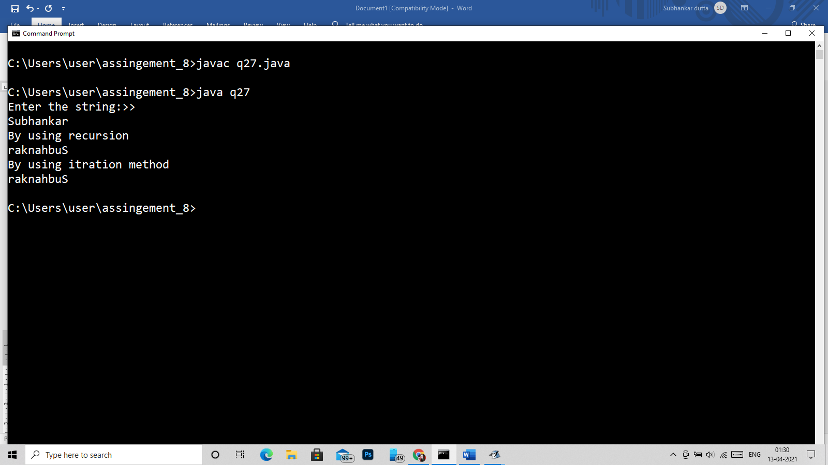

28)

import java.util.*;

class q28

{

public static void main(String args[])

{

Scanner in = new Scanner(System.in);

System.out.println("Enter the string:>> ");

String str = in.nextLine();

int len = str.length();

char st[] = new char[50];

st = str.toCharArray();

int i;

for(i=0;i<len;i++)

{

if(st[i]>='a'&&st[i]<='z')

st[i]=(char)((int)st[i]-32);

System.out.print(st[i]);

}

}

}

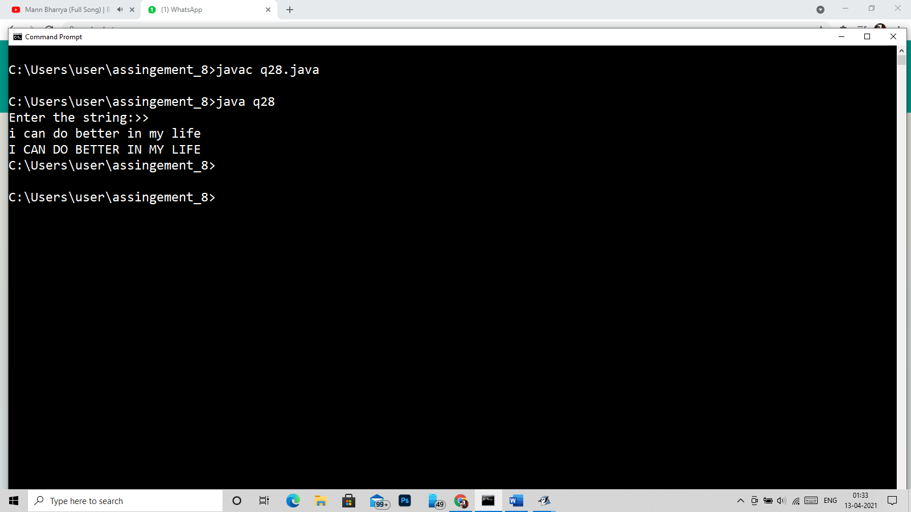

29)

import java.util.*;

class q29

{

public static void main(String args[])

{

Scanner in = new Scanner(System.in);

System.out.println("Enter the string:>> ");

String str1 = in.nextLine();

System.out.println("Enter the string:>> ");

String str2 = in.nextLine();

int len1 = str1.length();

char st1[] = new char[50];

st1 = str1.toCharArray();

int len2 = str2.length();

char st2[] = new char[50];

st2 = str2.toCharArray();

for(int i=0;i<len1;i++)

{

char c=st1[i];

for(int j=0;j<len2;j++)

{

if(st2[j]==c)

{

st2[j]='-';

}

}

}

for(int j=0;j<len2;j++)

{

if(st2[j]!='-')

System.out.print(st2[j]);

}

}

}

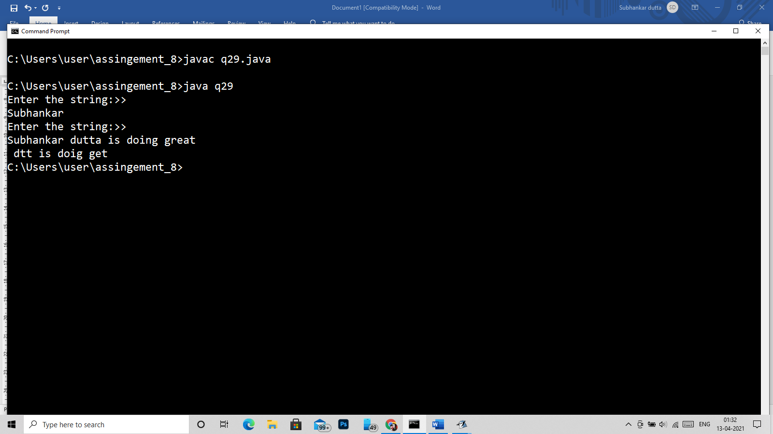

30)

import java.util.*;

/*

* Vouwl

*/

class q30

{

public static void main(String args[])

{

Scanner in = new Scanner(System.in);

System.out.println("Enter the string:>> ");

String str = in.nextLine();

int len = str.length(),flag=0;

char st[] = new char[100];

st = str.toCharArray();

int a=0,e=0,i=0,o=0,u=0;

for(int k = 0;k<len ;k++)

{

if(st[k]=='a'||st[k]=='A')

a++;

if(st[k]=='e'||st[k]=='E')

e++;

if(st[k]=='i'||st[k]=='I')

i++;

if(st[k]=='o'||st[k]=='O')

o++;

if(st[k]=='u'||st[k]=='U')

u++;

}

System.out.println("The occrunce of a is:>> "+a);

System.out.println("The occrunce of e is:>> "+e);

System.out.println("The occrunce of i is:>> "+i);

System.out.println("The occrunce of o is:>> "+o);

System.out.println("The occrunce of u is:>> "+u);

}

}

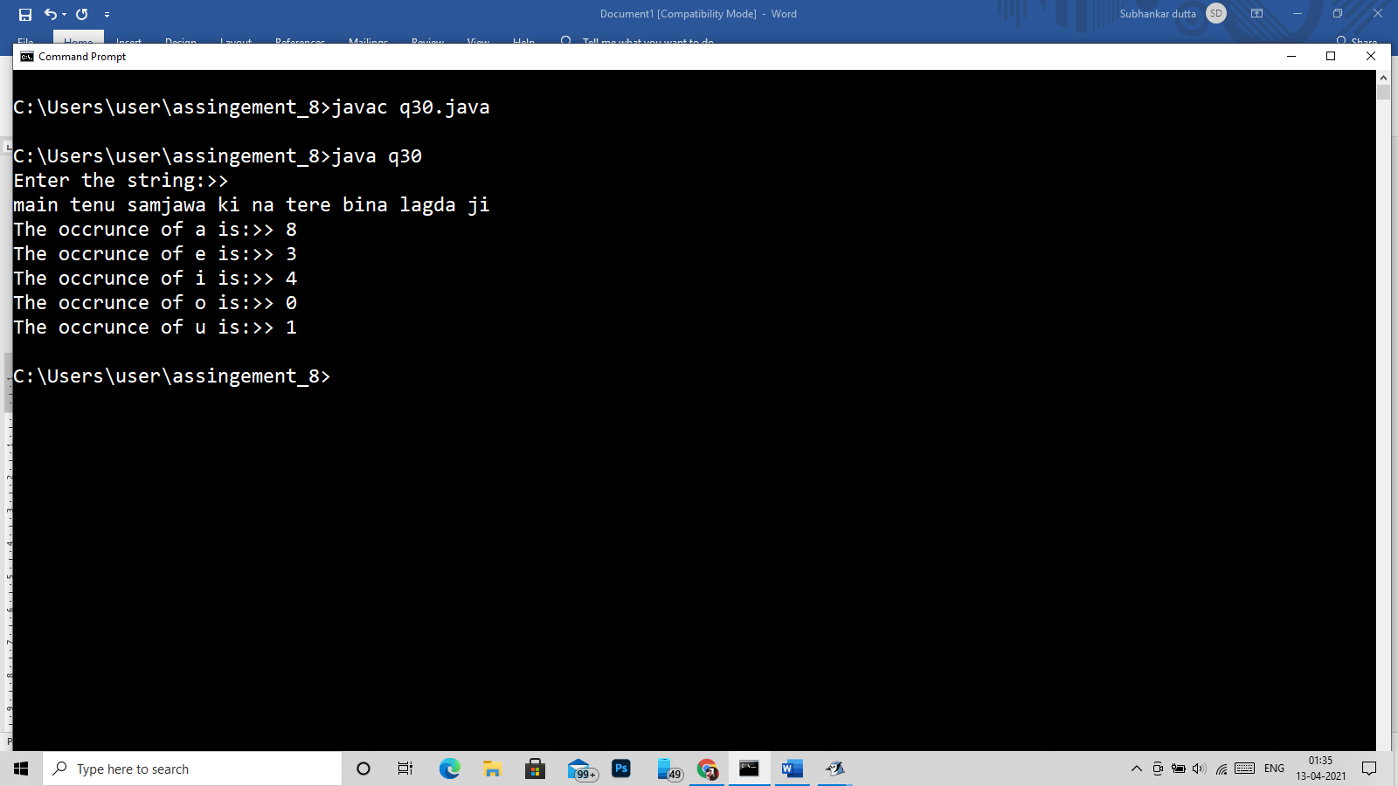

31)

import java.util.*;

class q31

{

public static void main(String args[])

{

Scanner in = new Scanner(System.in);

System.out.println("Enter the string:>> ");

String str = in.nextLine();

str=str+" ";

String minstr=" ",maxstr=" ";

int len = str.length(),flag=0;

char st[] = new char[50],minword[]=new char[20],maxword[]=new char[20],word[]=new char[20];

st = str.toCharArray();

int j=0,max=0,min=9999;

for(int i=0;i<len;i++)

{

if(st[i]!=' ')

{

word[j]=st[i];

j++;

}

else

{

word[j]='\0';

if(j>max)

{

maxstr = new String(word);

max=j;

}

if(j<min)

{

minstr = new String(word);

min=j;

}

j=0;

}

}

System.out.println("The Maximum word is:> "+maxstr);

System.out.println("The Minimum word is:> "+minstr);

}

}

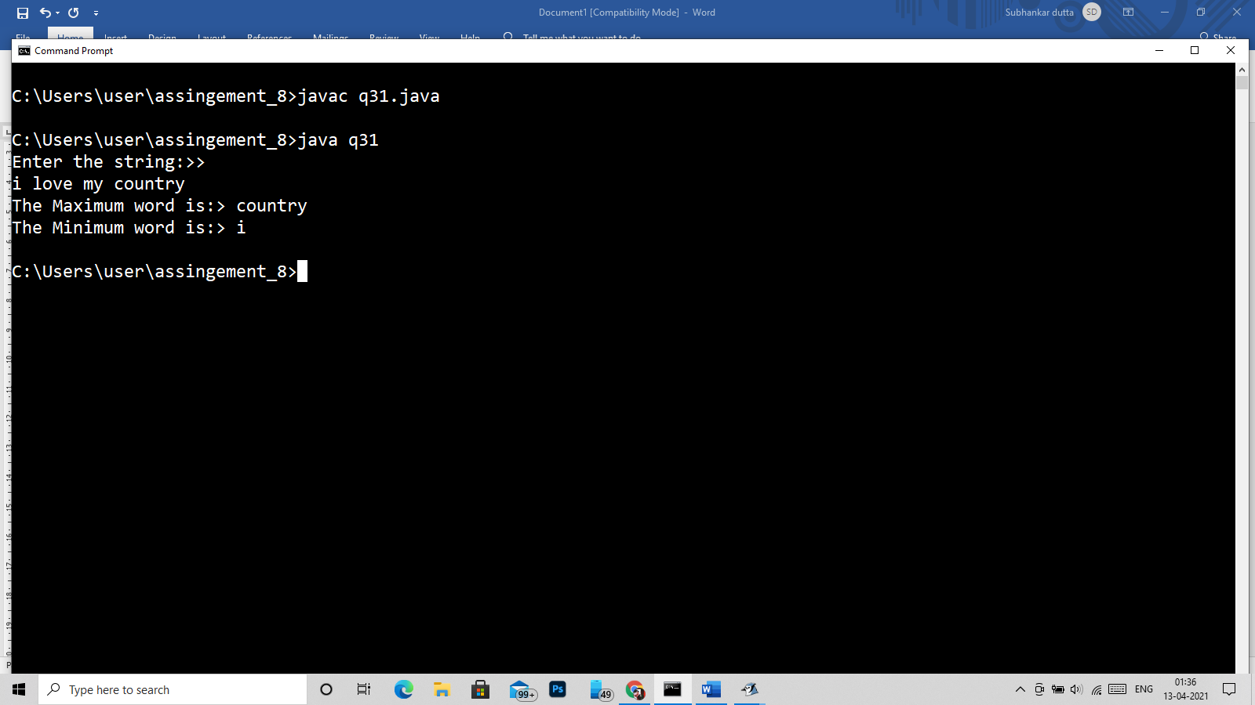

Q32)

import java.util.*;

class q32

{

public static void main(String args[])

{

Scanner in = new Scanner(System.in);

System.out.println("Enter the string:>> ");

String str = in.nextLine();

int len = str.length(),flag=0;

char st[] = new char[50];

st = str.toCharArray();

System.out.println("The first occurance is:> "+st[0]);

System.out.println("The last occurance is:> "+st[len-1]);

}

}

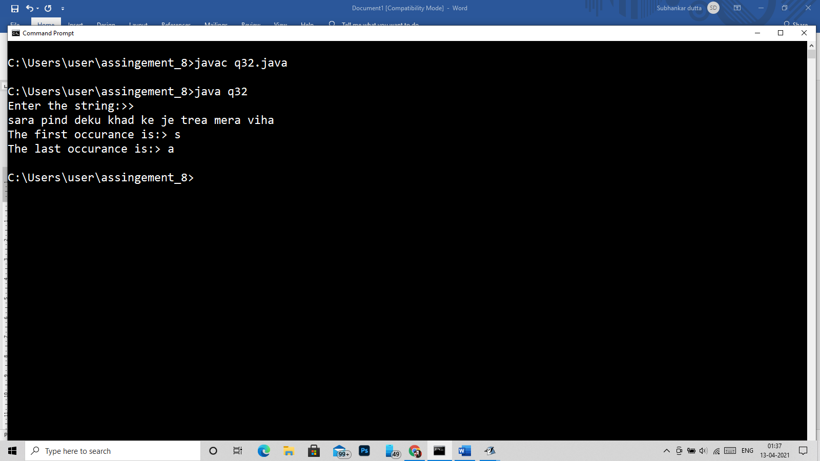

33)

import java.util.*;

class q33

{

public static void main(String args[])

{

Scanner in = new Scanner(System.in);

System.out.println("Enter the string:>> ");

String str = in.nextLine();

int len = str.length(),flag=0;

char st[] = new char[50];

st = str.toCharArray();

for(int i =0;i<len;i++)

{

int c=0;

for(int j=1;j<=i;j++)

{

if(i%j==0)

c++;

}

if(c==2)

System.out.print(st[i]);

}

}

}

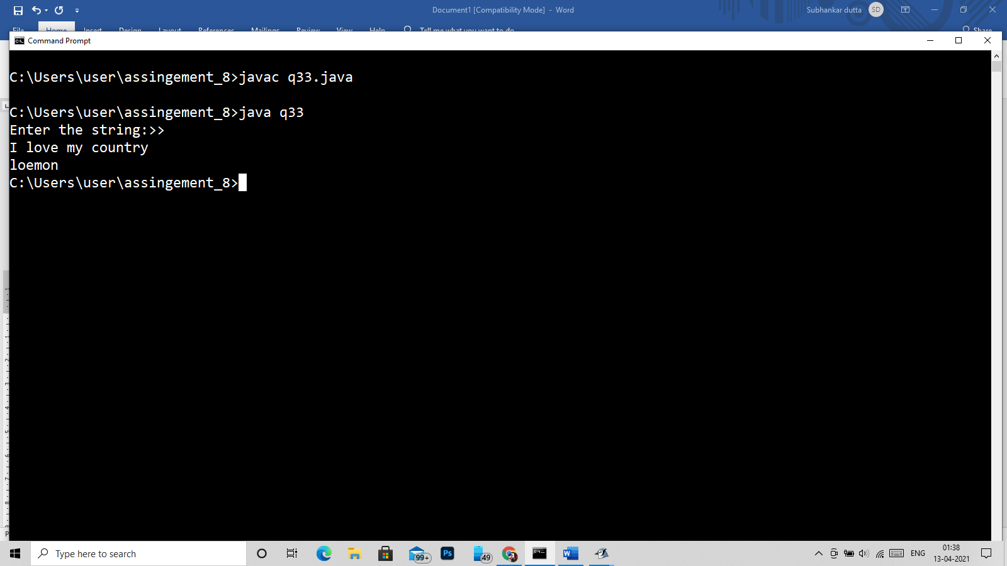

Q34)

import java.util.*;

class q34

{

public static void main(String args[])

{

Scanner in = new Scanner(System.in);

System.out.println("Enter the string:>> ");

String str = in.nextLine();

int len = str.length(),flag=0;

char st[] = new char[50];

st = str.toCharArray();

for(int i = 0;i<len;i++)

{

for(int j=i+1;j<len;j++)

{

if(st[i]==st[j]||st[j]==' ')

st[j]='_';

}

}

for(int i=0;i<len;i++)

{

if(st[i]!='_')

System.out.print(st[i]);

}

}

}

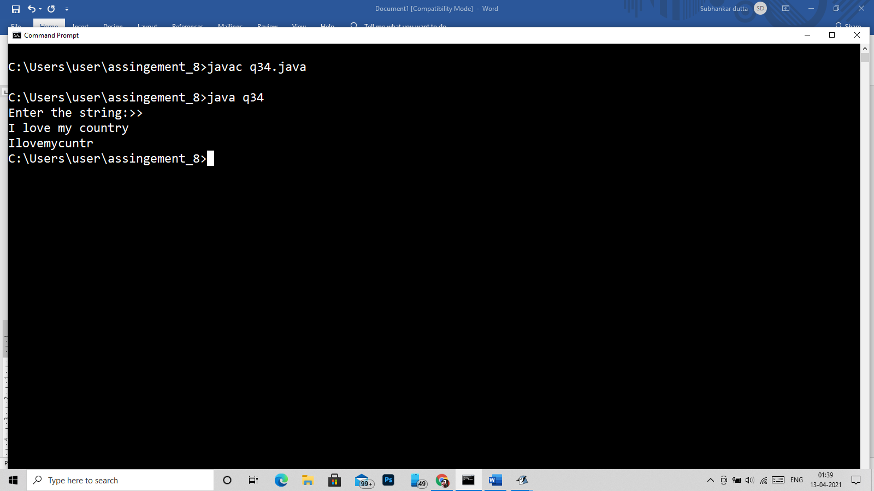

35)

import java.util.*;

class q35

{

public static void main(String args[])

{

Scanner in = new Scanner(System.in);

System.out.println("Enter the string:>> ");

String str1 = in.nextLine();

System.out.println("Enter the charecter or string to be replaced:>> ");

String str3 = in.nextLine();

System.out.println("Enter the new charecter or string to be replaced:>> ");

String str2 = in.nextLine();

System.out.println("in index : "+str1.replaceFirst(str3,str2));

}

}

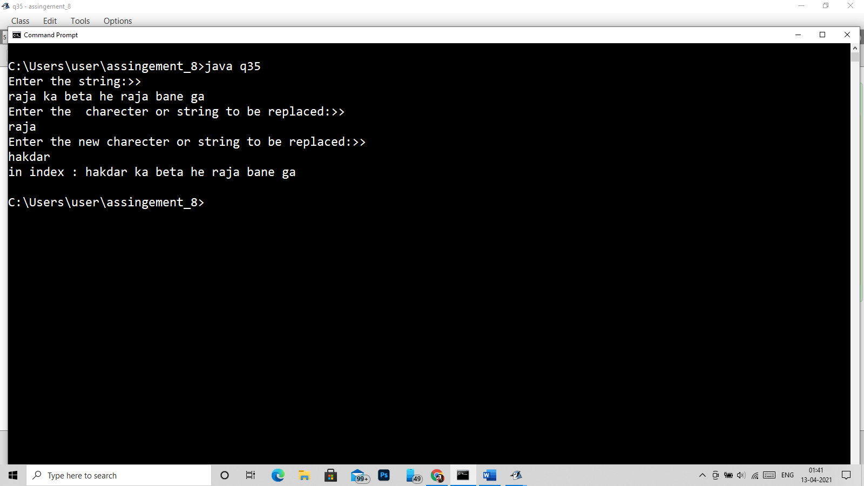

36)

import java.util.*;

class q36

{

public static void main(String args[])

{

Scanner in = new Scanner(System.in);

System.out.println("Enter the string:>> ");

String str = in.nextLine();

System.out.println("Enter the word>> ");

String scword=in.next();

System.out.println(str.lastIndexOf(scword));

}

}

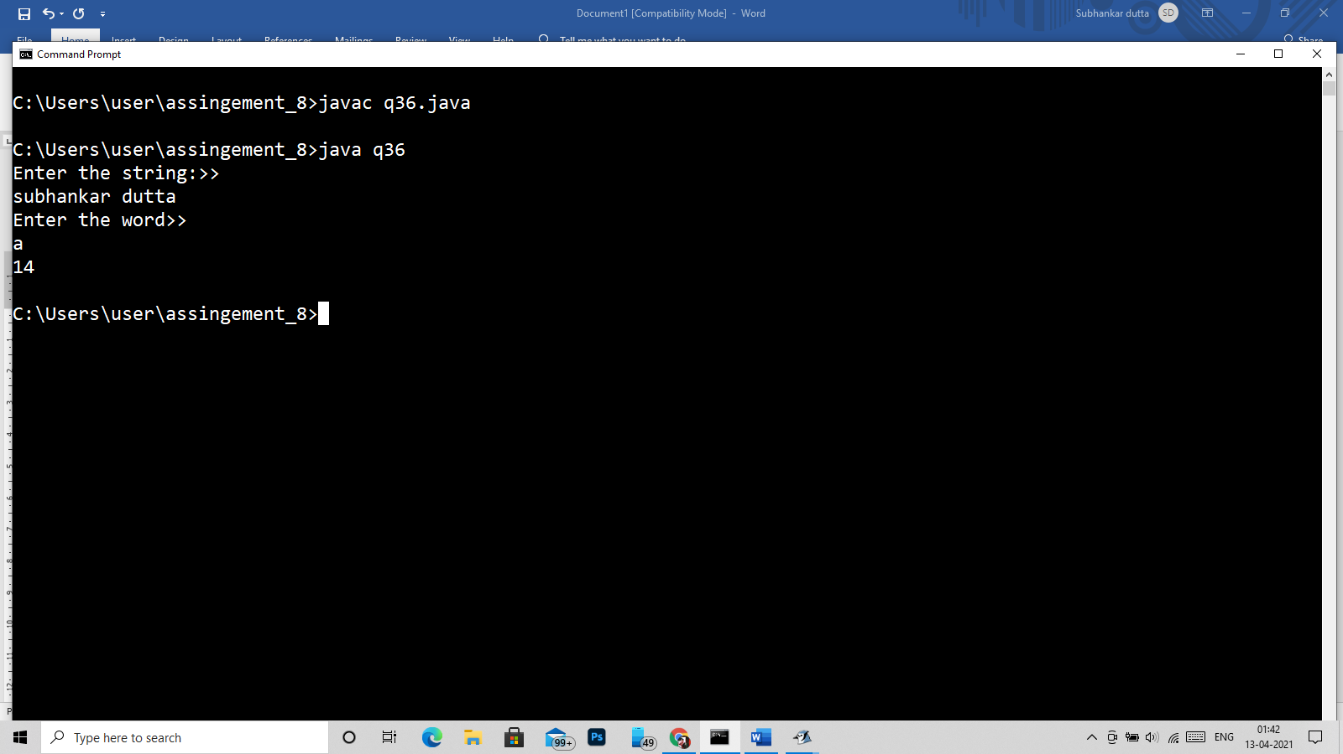

37)

import java.util.*;

class q37

{

public static void main(String args[])

{

Scanner in = new Scanner(System.in);

System.out.println("Enter the string:>> ");

String str = in.nextLine();

System.out.println("Enter the word or char:> ");

String sc = in.nextLine();

System.out.println("The index is:>> "+str.indexOf(sc));

}

}

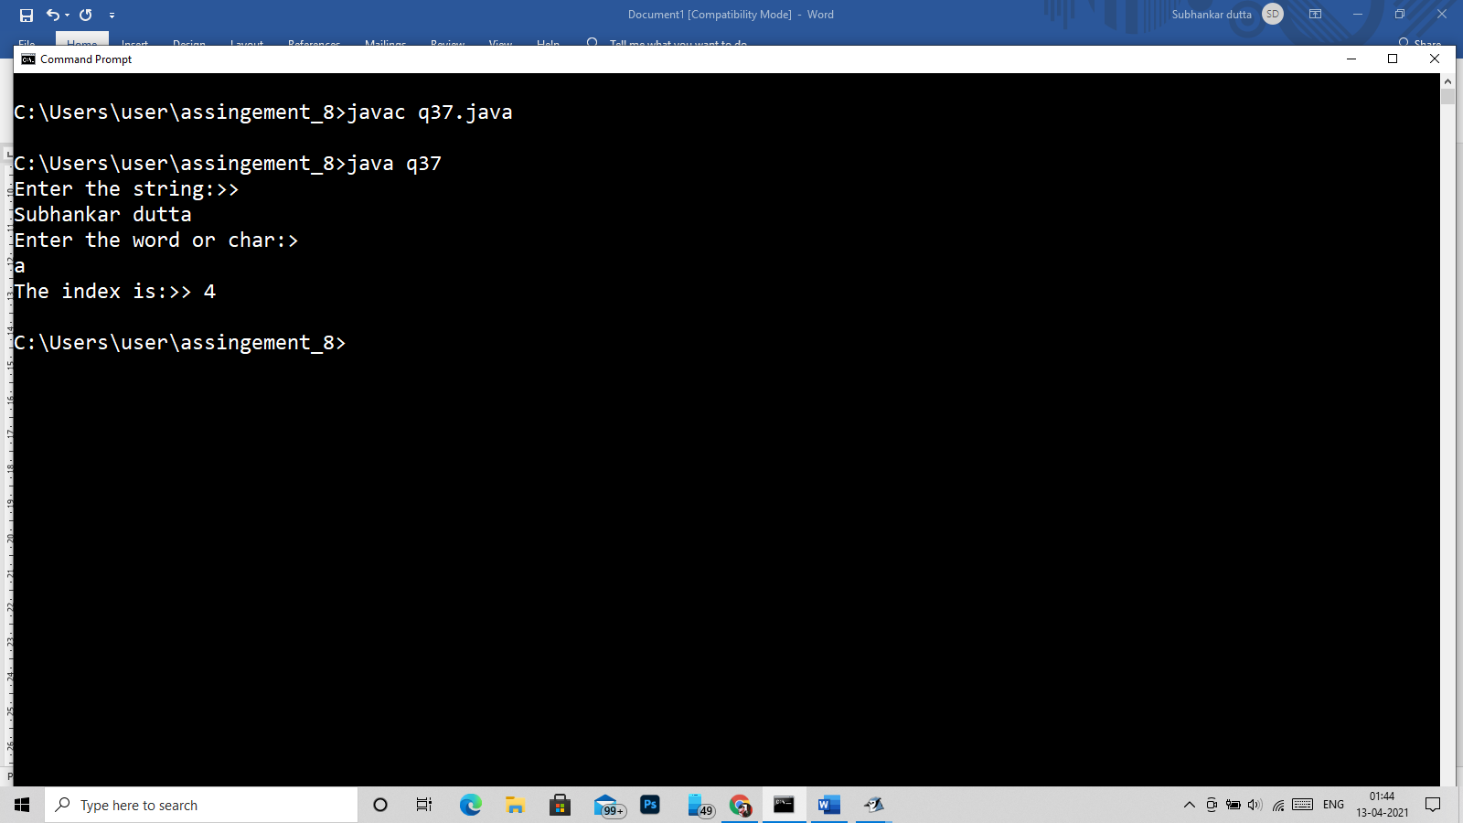

Q38)

import java.util.*;

class q38_and_q39

{

public static void main(String args[])

{

Scanner in = new Scanner(System.in);

System.out.println("Enter the string:>> ");

String str = in.nextLine();

int len = str.length();

for(int i=0;i<len;i++)

{

System.out.println(str.charAt(i)+":"+(int)str.charAt(i));

}

}

}

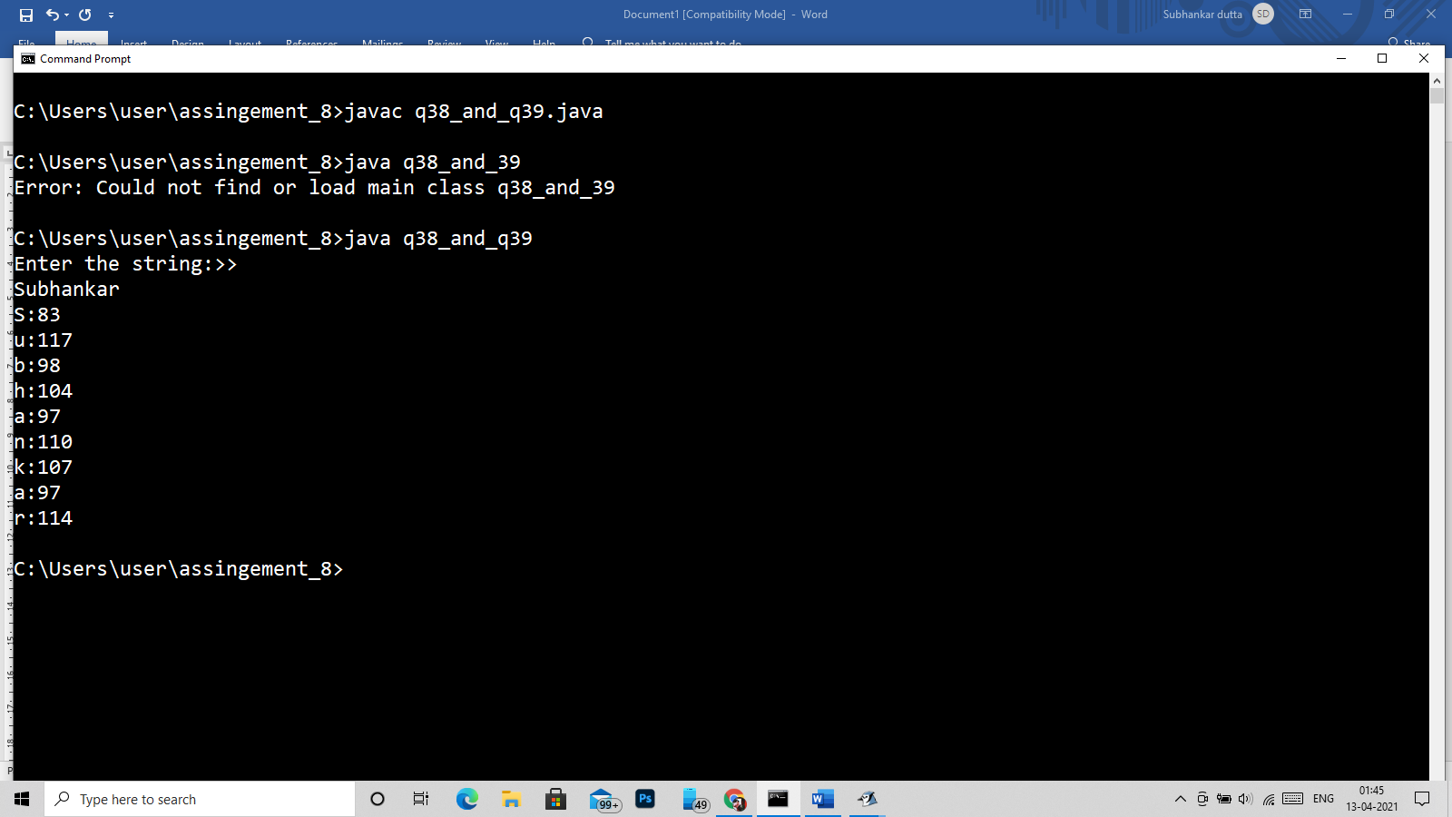

39)

import java.util.*;

class q38_and_q39

{

public static void main(String args[])

{

Scanner in = new Scanner(System.in);

System.out.println("Enter the string:>> ");

String str = in.nextLine();

int len = str.length();

for(int i=0;i<len;i++)

{

System.out.println(str.charAt(i)+":"+(int)str.charAt(i));

}

}

}

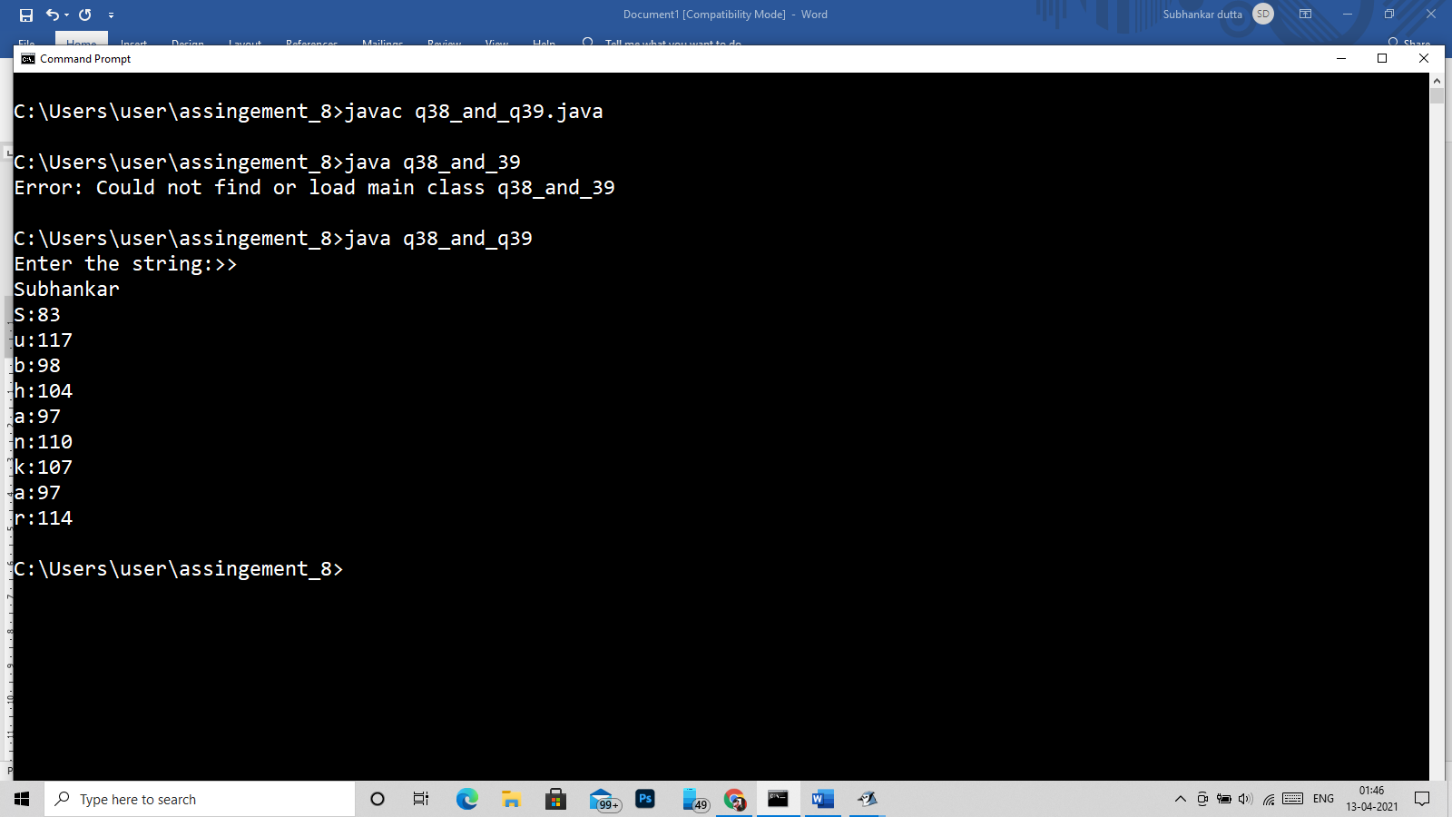

40)

import java.util.*;

class q40

{

public static void main(String args[])

{

Scanner in = new Scanner(System.in);

System.out.println("Enter the string:>> ");

String str1 = in.nextLine();

System.out.println("Enter the string:>> ");

String str2 = in.nextLine();

int len1 = str1.length();

char st1[] = new char[50];

st1 = str1.toCharArray();

int len2 = str2.length();

char st2[] = new char[50];

st2 = str2.toCharArray();

int i;

if(len1==len2)

{

for(i=0;i<len1;i++)

{

if(st1[i]!=st2[i])

{

break;

}

}

if(i==len1)

{

for(i=0;i<len1;i++)

{

System.out.println(st1[i]);

}

}

else

{

System.out.println("No all charecter are not matched!! is incorrect <3 XD");

}

}else

{

System.out.println("No length is not matched it is incorrect <3 XD");

}

}

}

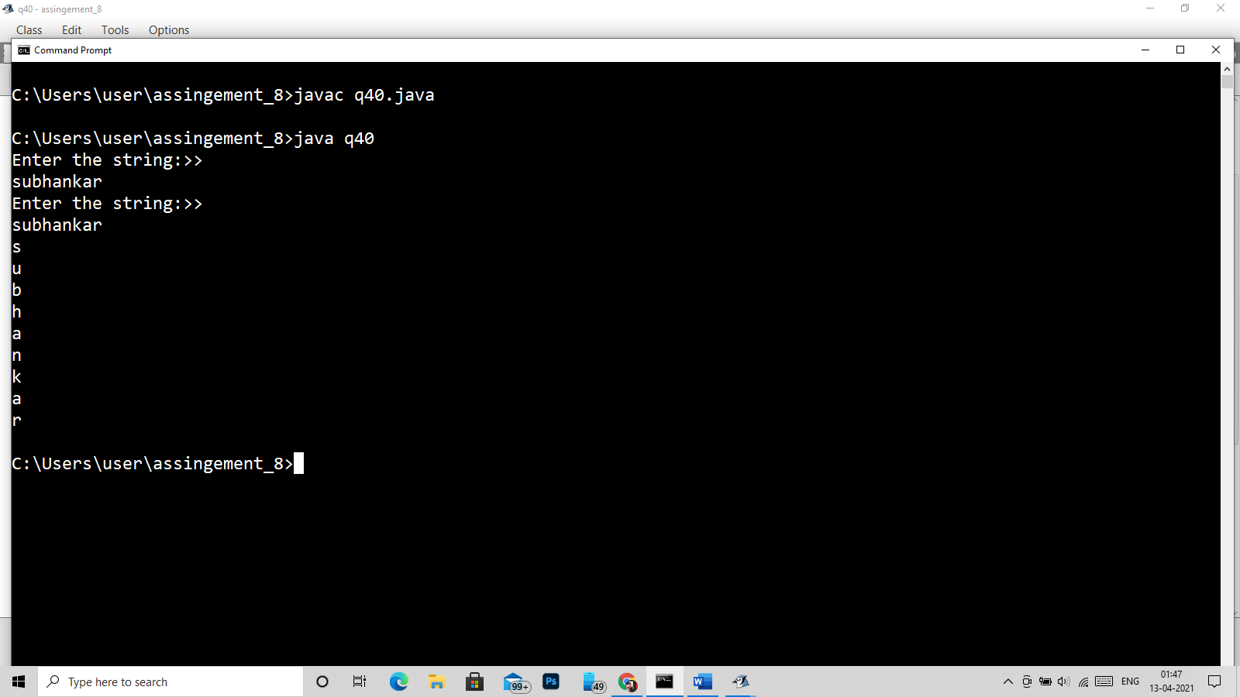

41)

import java.util.*;

class q41

{

public static void main(String args[])

{

/*

* Sentence

* assassinnation

*

*

*/

Scanner in = new Scanner(System.in);

System.out.println("Enter the word:>> ");

String str;

str=in.nextLine();

System.out.println("Enter the charecter:>> ");

char ch = in.next().charAt(0);

char word[] = new char[100];

int len = str.length();

word = str.toCharArray();

char letter;

int i=0,j=0,c=0;

while(i<len)

{

letter=word[i];

j=i+1;

if(ch==letter||ch==(char)((int)letter-32)||ch==(char)((int)letter+32))

{

c++;

}

i++;

}

System.out.println("The occurence of letter "+ch+" is:>> "+c);

}

}

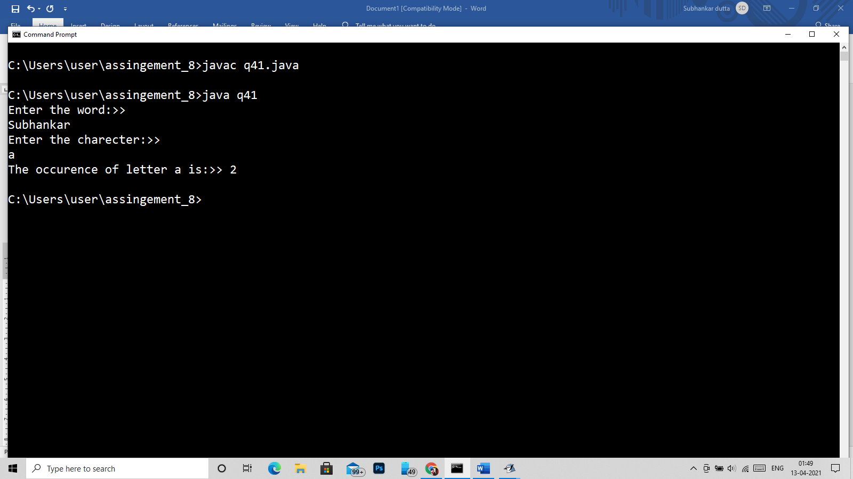

42)

import java.util.*;

class q42

{

public static void main(String args[])

{

/*

* Sentence

* assassinnation

*

*

*/

Scanner in = new Scanner(System.in);

System.out.println("Enter the word:>> ");

String str;

str=in.nextLine();

char word[] = new char[100];

int len = str.length();

word = str.toCharArray();

char letter;

int i=0,j=0,c=0;

while(i<len)

{

letter=word[i];

j=i+1;

c=1;

while(j<len)

{

if(word[j]==letter||word[j]==(char)((int)letter-32)||word[j]==(char)((int)letter+32))

{

c++;

word[j]=' ';

}

j++;

}

if(word[i]!=' ')

System.out.println("The occurence of letter "+word[i]+" is:>> "+c);

i++;

}

}

}

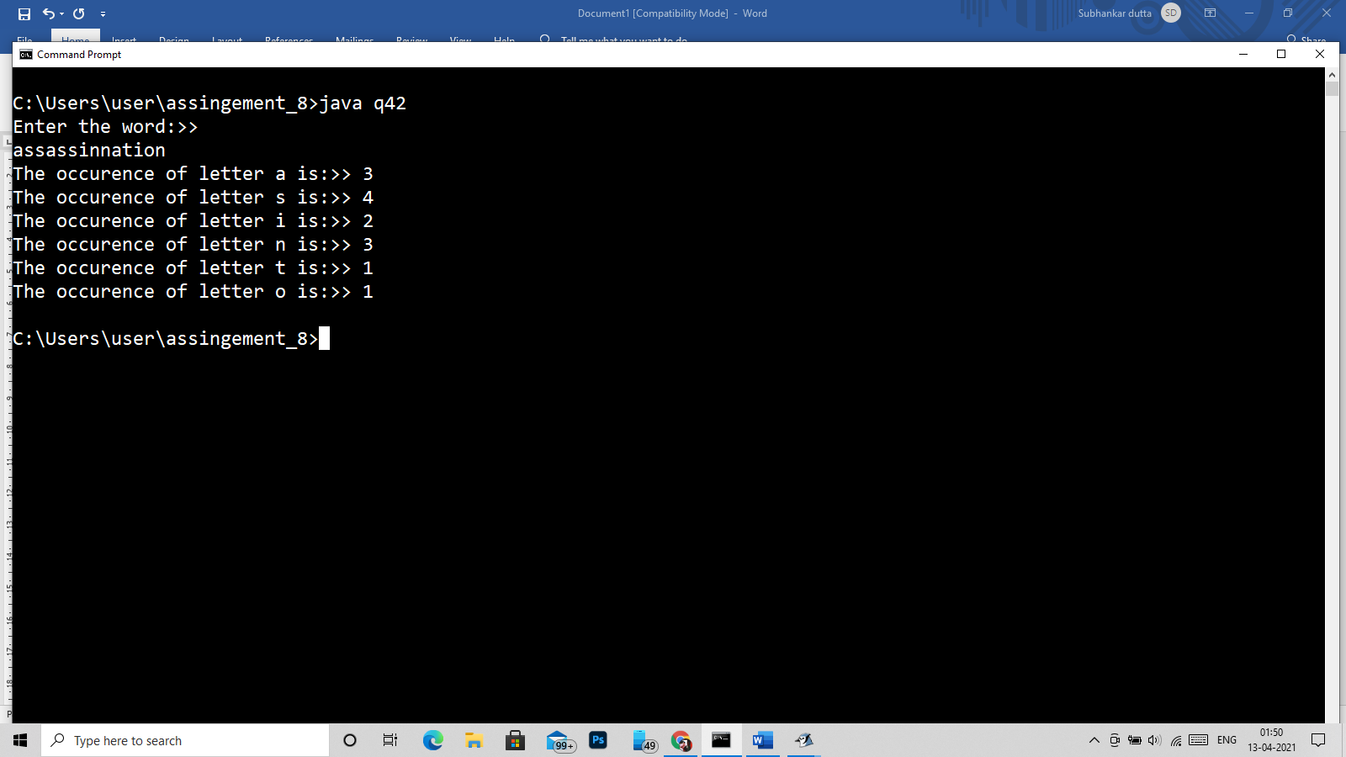

43)

import java.util.*;

class q43 {

static int lcs(String str1, String str2, int m, int n)

{

int L[][] = new int[m + 1][n + 1];

int i, j;

for (i = 0; i <= m; i++) {

for (j = 0; j <= n; j++) {

if (i == 0 || j == 0)

L[i][j] = 0;

else if (str1.charAt(i - 1)

== str2.charAt(j - 1))

L[i][j] = L[i - 1][j - 1] + 1;

else

L[i][j] = Math.max(L[i - 1][j],

L[i][j - 1]);

}

}

// L[m][n] contains length of LCS

// for X[0..n-1] and Y[0..m-1]

return L[m][n];

}

// function to find minimum number

// of deletions and insertions

static void printMinDelAndInsert(String str1,

String str2)

{

int m = str1.length();

int n = str2.length();

int len = lcs(str1, str2, m, n);

System.out.println("Minimum number of "

+ "deletions = ");

System.out.println(m - len);

System.out.println("Minimum number of "

+ "insertions = ");

System.out.println(n - len);

}

// Driver code

public static void main(String[] args)

{

Scanner in = new Scanner(System.in);

System.out.println("Enter the string1:> ");

String str1=in.nextLine();

System.out.println("Enter the string1:> ");

String str2=in.nextLine();

printMinDelAndInsert(str1, str2);

}

}

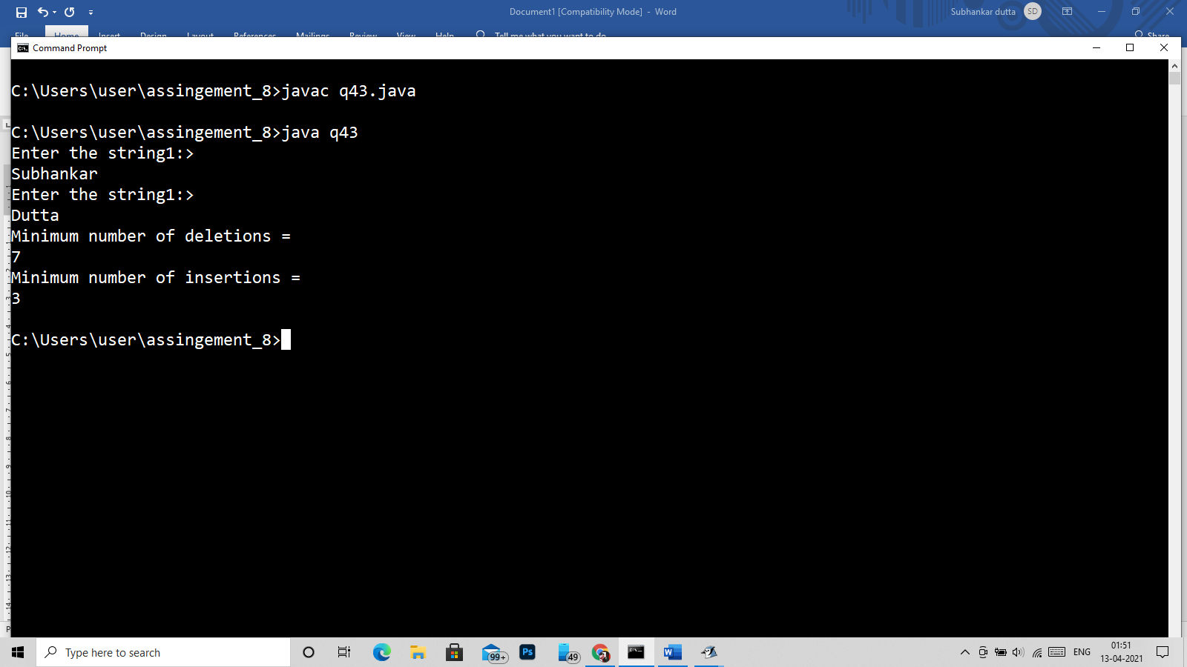

44)

public class q44 {

public static void main(String[] argv) {

boolean isDate = false;

String date1 = "8-05-1988";

String date2 = "08/04/1987";

String datePattern = "\\d{1,2}-\\d{1,2}-\\d{4}";

isDate = date1.matches(datePattern);

System.out.println("Date :"+ date1+": matches with the this date Pattern:"+datePattern+"Ans:"+isDate);

isDate = date2.matches(datePattern);

System.out.println("Date :"+ date2+": matches with the this date Pattern:"+datePattern+"Ans:"+isDate);

}

}

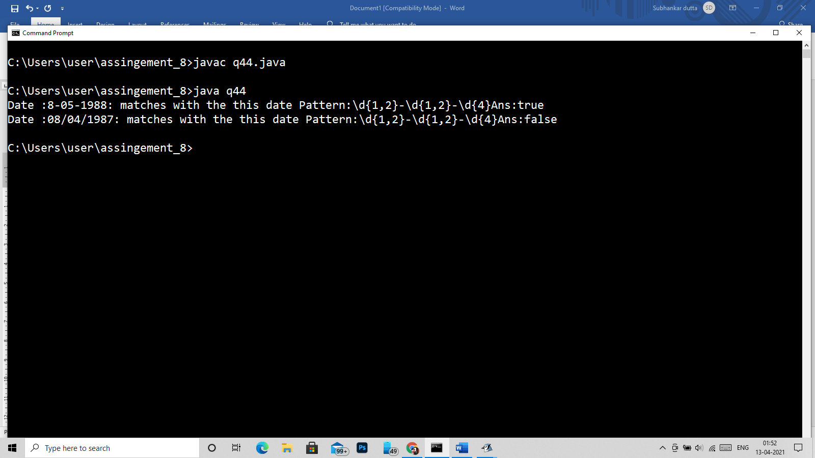

45)

import java.util.regex.Matcher;

import java.util.regex.Pattern;

import java.util.*;

class q45

{

public static boolean isValid(String email)

{

String emailRegex = "^[a-zA-Z0-9_+&*-]+(?:\\."+

"[a-zA-Z0-9_+&*-]+)*@" +

"(?:[a-zA-Z0-9-]+\\.)+[a-z" +

"A-Z]{2,7}$";

Pattern pat = Pattern.compile(emailRegex);

if (email == null)

return false;

return pat.matcher(email).matches();

}

public static void main(String[] args)

{

Scanner in = new Scanner(System.in);

System.out.println("enter the email:>> ");

String email =in.nextLine();

if (isValid(email))

System.out.print("Yes");

else

System.out.print("No");

}

}

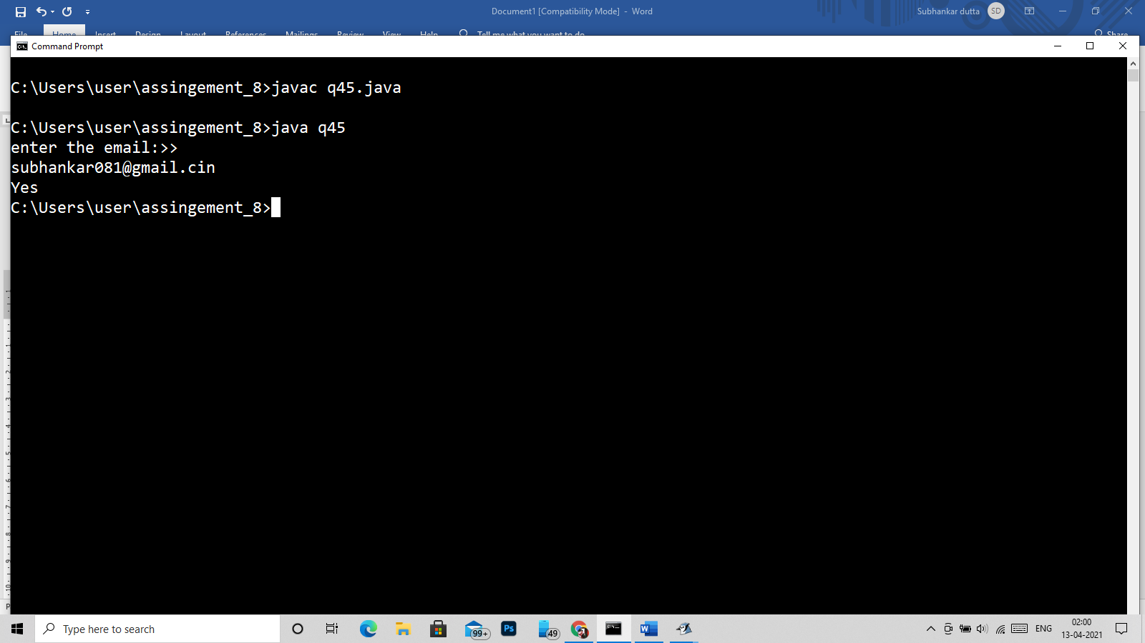

46)

import java.util.*;

class q46

{

public static void main(String args[])

{

StringBuffer s1=new StringBuffer("Hello");

StringBuffer s2=new StringBuffer("Hello");

System.out.println("s3=="+System.identityHashCode(s1));

System.out.println("s4=="+System.identityHashCode(s2));

}

}

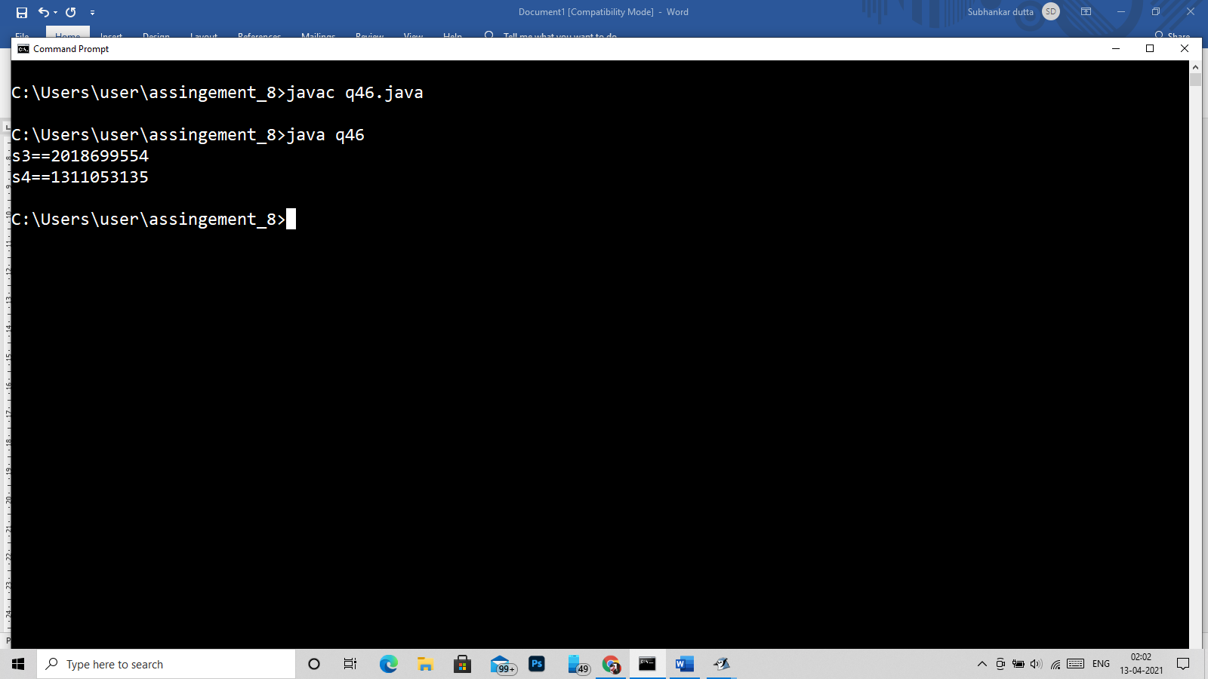

47)

import java.util.*;

class q47

{

public static void main(String args[])

{

Scanner in = new Scanner(System.in);

StringBuffer str = new StringBuffer("HEllp hlo");

System.out.println("Text:> "+str+"::"+str.getClass().getName());

}

}

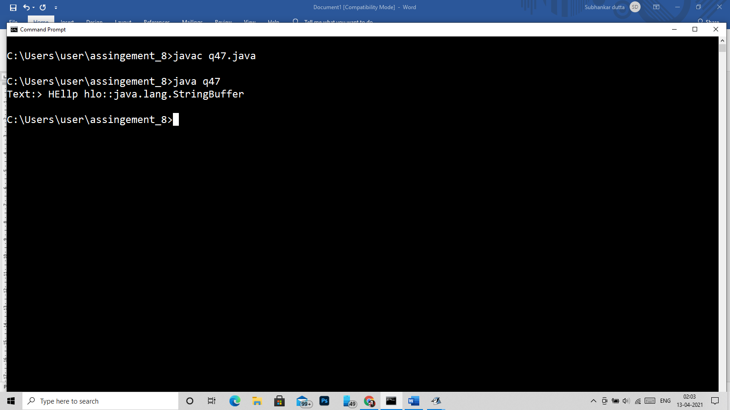

48)

import java.util.*;

class q48

{

public static void main(String args[])

{

Scanner in = new Scanner(System.in);

System.out.println("Enter Your name:>> ");

String str = in.nextLine();

System.out.println("Hello! "+str);

}

}

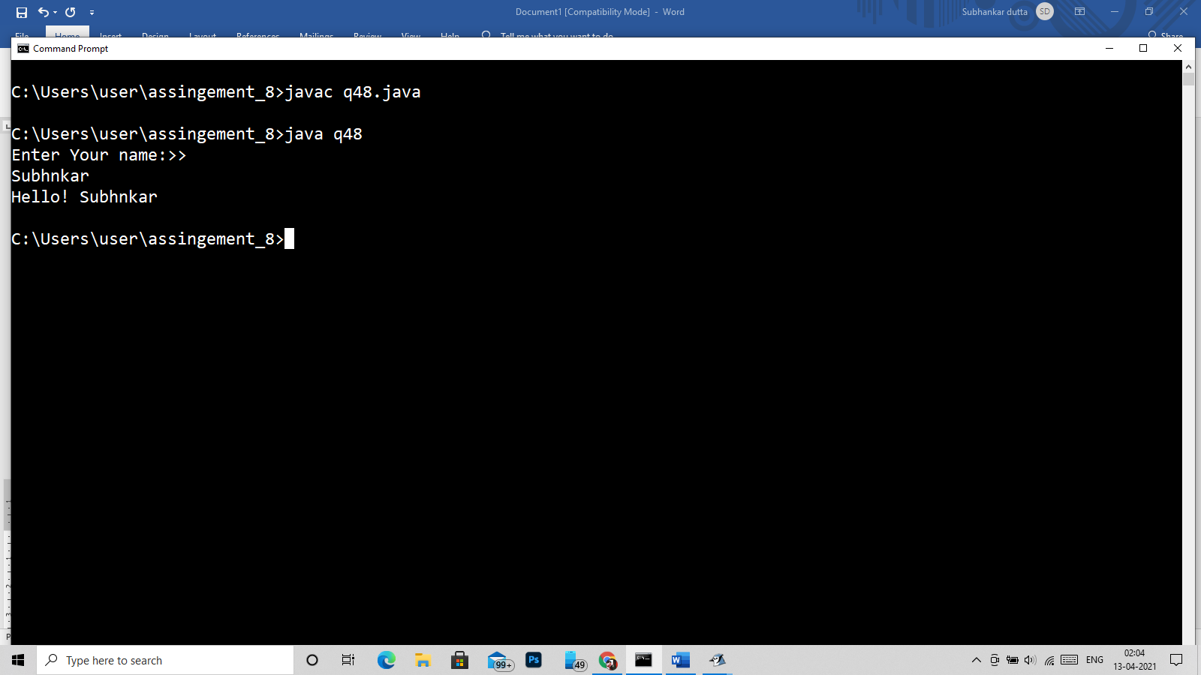

49)

import java.util.*;

class q49

{

public static void main(String args[])

{

Scanner in = new Scanner(System.in);

System.out.println("Enter the string:> ");

String str=in.nextLine();

str = str+" ";

int len=str.length();

int i=0,j=0;

char st[] = str.toCharArray(),word[]= new char[20];

for(char ch : st)

{

if(ch!=' ')

{

word[j]=ch;

j++;

}

else

{

word[j]='\0';

String star = new String(word);

System.out.println(star);

j=0;

word = new char[20];

}

}

}

}

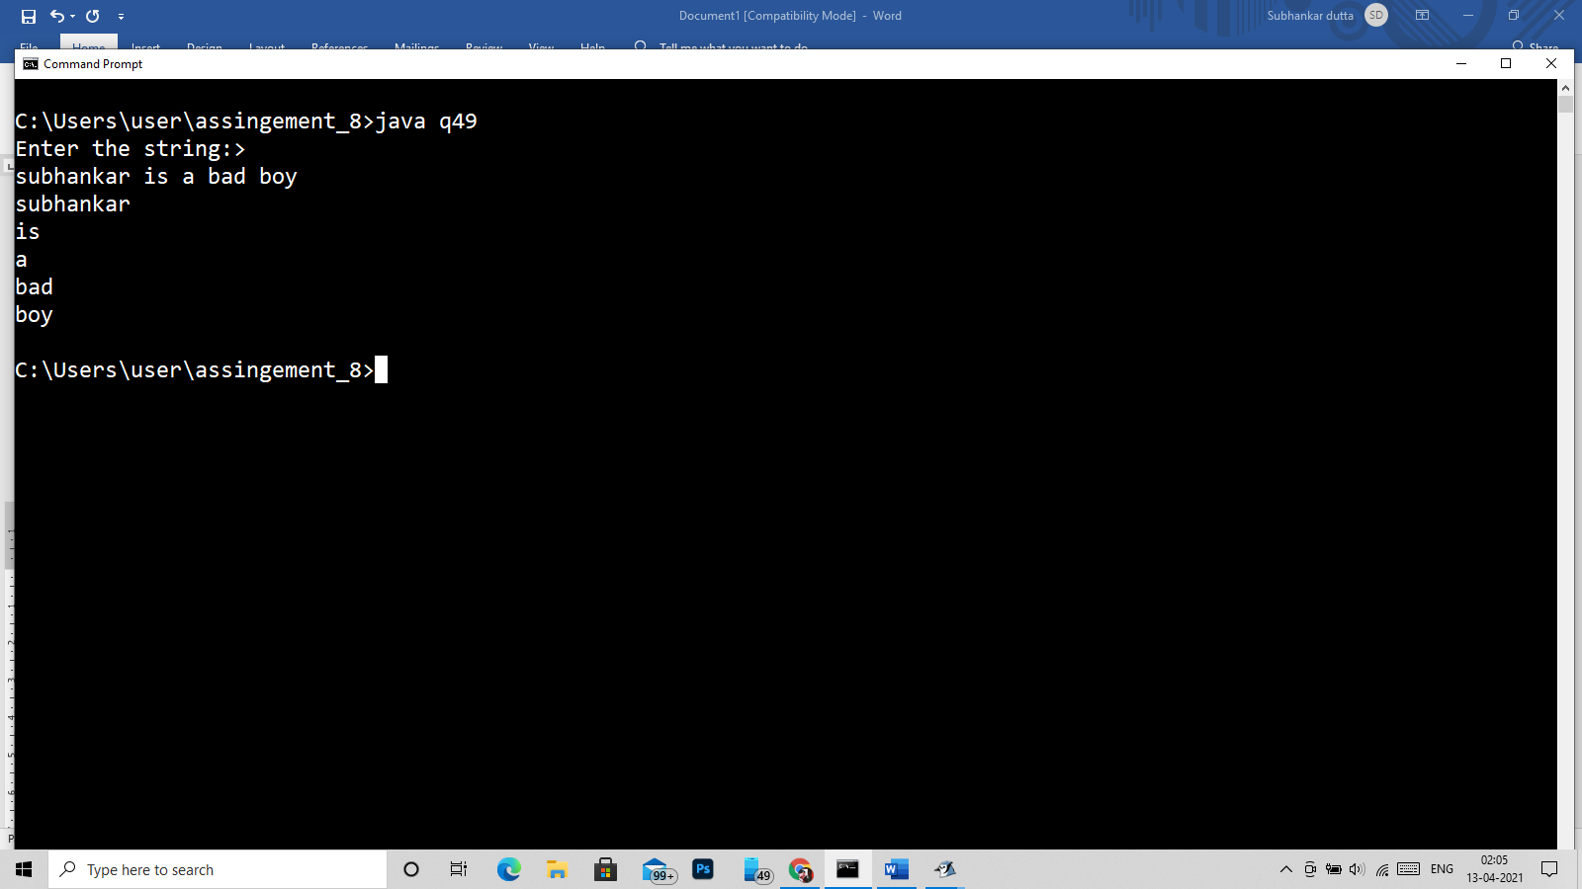

50)

import java.util.*;

class q50

{

public static void main(String args[])

{

Scanner in = new Scanner(System.in);

System.out.println("Enter the string:>> ");

String str = in.nextLine();

int len = str.length(),flag=0;

char st[] = new char[100];

st = str.toCharArray();

int i,j=0;

for(i=0;i<len ;i++)

{

if(st[i]==' ')

j++;

}

System.out.println("total number of words are :> "+(j+1));

}

}

